RM module work description

Jooby Development
- Message documentation
- Message encoders/decoders
- Message encoders/decoders GUI (Demo)
- API for interacting with Jobby devices. Other documentation
- Command and Parameter Examples

Beginning of work
It is necessary to know the module factory parameters to instal module in NS correctly (they are available in specification):
- Activation method in the LoraWAN network - ABP (Activation by personalization) or OTAA (Over the Air Activation)
- Keys APPSKEY[16], NETSKEY[16] - ABP or APPKEY[16] - OTAA

Time and date
The Radio module and server times need to be synchronized. It is necessary to correct the modulating time when it leaves the server. Possible deviation no more than 30 seconds.
Device time management
The time is transmitted as a 4-byte counter. This is the time in seconds since the year 2000. The module time must be synchronized with the server time. The time can be set using the commands: SET_TIME and CORRECT_TIME. The SET_TIME command is for initial time setting and for adjustments greater than +/-128 seconds. Adjusting the time backwards may result in the loss of hourly data. Further, the server must correct the module time if it deviates from the server time. The recommended allowable time deviation is no more than 30 seconds; if it is exceeded, the time is corrected using the CORRECT_TIME command.

Battery
Once a day, the module measures the battery parameters: battery voltage without load and battery voltage under resistor load (150 Ohm for modules on WLE). These data and the calculated internal resistance value are transmitted once a day also. Based on the measurement results, it is possible to start the battery depassivation process. In this case, the DEPASS_DONE event is logged.

Magnetic field sensor
A magnetic field sensor is installed in the module. This sensor is used to send current pulse counter to server. In case of short magnetic influence (more than 2 sec and less than 20 sec), the current pulse counter data GET_CURRENT will be sent to the server.
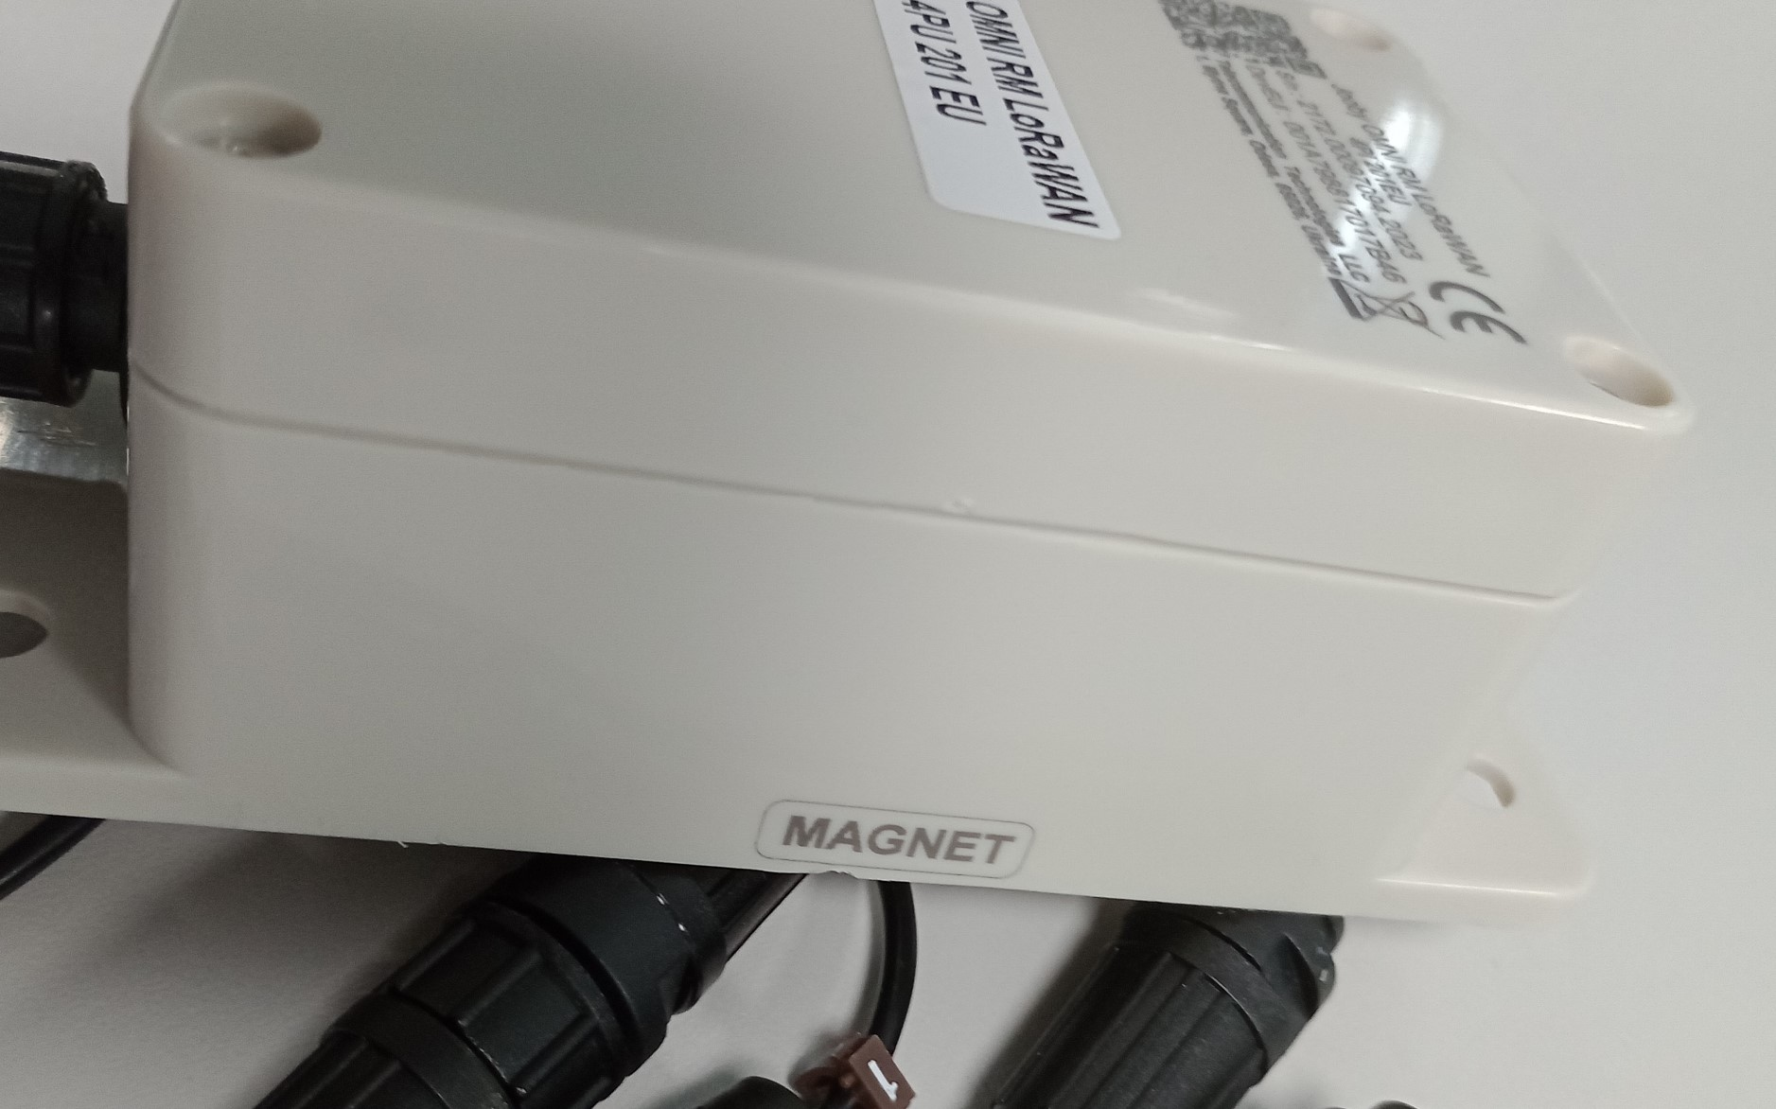

Activation/Deactivation
- Installation. Activation
The module is activated after connecting the Jooby Splitter 1x4PU/1x2PU to the module’s port. The pulse counter in the module is continuously polled. Activation means that the module starts transmitting data frames via the radio channel.
Upon the occurrence of the INSERT and ACTIVATE events, the module will send NEW_EVENT frames containing the INSERT and ACTIVATE events and the corresponding event timestamps. The NEW_EVENT frame will also include a CURRENT message containing the current pulse counter data.
If the Jooby Splitter 1x4PU/1x2PU is disconnected from the module, the module will be deactivated after 30 seconds. A NEW_EVENT frame will be sent to the Network Server with the REMOVE and DEACTIVATE events, along with the CURRENT data. The event time is transmitted as part of the event data.

Consumption data
Once activated, the module sends consumption data regularly. By default, the module transmits hourly consumption data at an interval of about 4 hours + a pseudo-random component ranging from 0 to 17 minutes. The frequency of sending data can be changed, but the period cannot be less than 10 minutes and more than 36 hours. You can set the type of data to be transferred. It is possible to transfer current, hourly, daily data. It is also possible to transmit hourly and daily data simultaneously (in one frame). To select the type of data to be transmitted, use parameter 5 (Type of data to be output). Hourly data is stored in the archive, the maximum archive depth is 6 months. Daily consumption data is also stored in the archive, the maximum depth is 2 years. The depth of the archives does not change configurationally.

Absolute data
The device supports Absolute data mode. In Absolute data you can put real meters value.
First of all you have to setup and enable Absolute Data on module with commands:
Example:
- Setup absolute data - 030a17000028c28200000b072f. That command setup absolute data with next fields
"id": 23,
"value": 2823,
"meterValue": 10434,
"pulseCoefficient": 10
id - Parametr ID
value - Counter value on module. You can get it with command 070052, or module send it after activate/deactivate events
meterValue - Real meter value on module multiplied by pulseCoefficient. In that example the meter has readings 104,34 cubic meters
pulseCoefficient - Pulse Coefficient of meter. If pulse coefficient of meter is 0,01 then that valuer should be 10, if pulse coefficient of meter is 0,1 then that valuer should be 100
- After setup you have to enable Absolute Data with command - 030218014d
In response you will get 0302170142 - Means “Absolute Data” enabled
For example module get 3 impulse. With command 1f0f0045 possible to get current Absolute Data. in response will be 1803018a161f0f040182c551d0.
Current counter value of module "CurrentMC"
"value": 2826,
"index": 1
and Absolute Data "ExAbsCurrentMC"
"pulseCoefficient": 10,
"value": 10437,
"index": 1
Here we can see Meter Readings 10437. That means 104,37 cubic meters
Module send Absolute Data in Reporting Data Interval

Events
Device events
All events are recorded in the archive. Archive capacity - not less than 256 events and not more than 512 events. The event log records the time of the event, the event ID, and the LAST_EVENT sequence number. The event number is incremented with each entry. The event number is passed to the server with the LAST_EVENTS command, which is added to every UPLINK frame sent without a request. There is no priority for messages in the archive. Events are recorded in a cycle. Archives can be requested from the most recent to the oldest and from a specific time.

Commands
There are 2 types of command direction:
- downlink - request (sent from server to device)
- uplink - response or event (sent from device to server)
- Downlink commands
- Uplink commands

Parameter types
Description of parameter types

