Radio modules universal/multichannel  Jooby Devices  - Sensors and Cables | 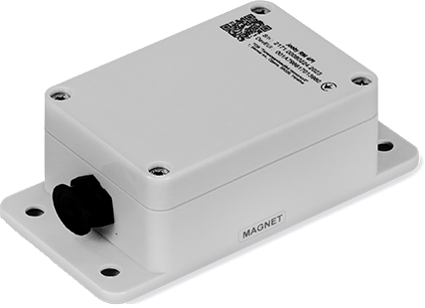

- Description of work. Commands. Parameters
- Command and Parameter Examples
Model | Аppearance | Resource type | Applicability | External antenna | Documentation
Jooby OMNI RM LoRaWAN 4PU | 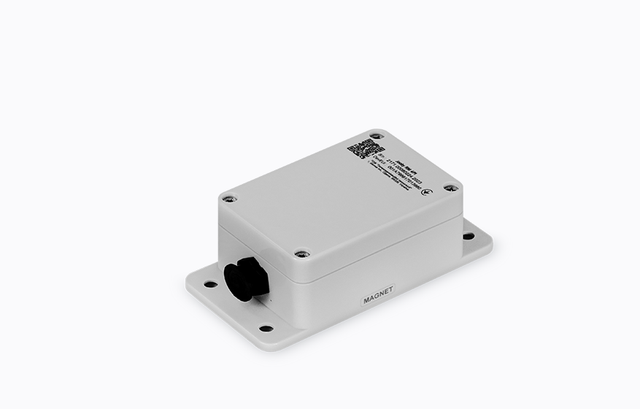 | Universal | Universal. External Sensor connection required | - | Сonnector pinout

Jooby Development
- Message documentation
- Message encoders/decoders
- Message encoders/decoders GUI (Demo)
- API for interacting with Jobby devices. Other documentation

