Xylem Sensus HRI-B - Connection
To connect use the Jooby Cable 1PI 100.
- Connect the Jooby Cable 1PI 100 and the Sensor cable according to the diagram:
Connection diagram:
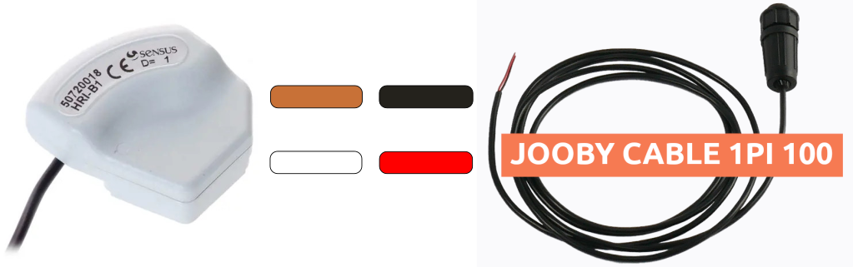
- Connection to Radio Module (RM)

