Test Page
LoRaWAN specification. Introduction. Basic concepts and end-device classes
LoRaWAN specification. The end-devices activation
Remote data collection

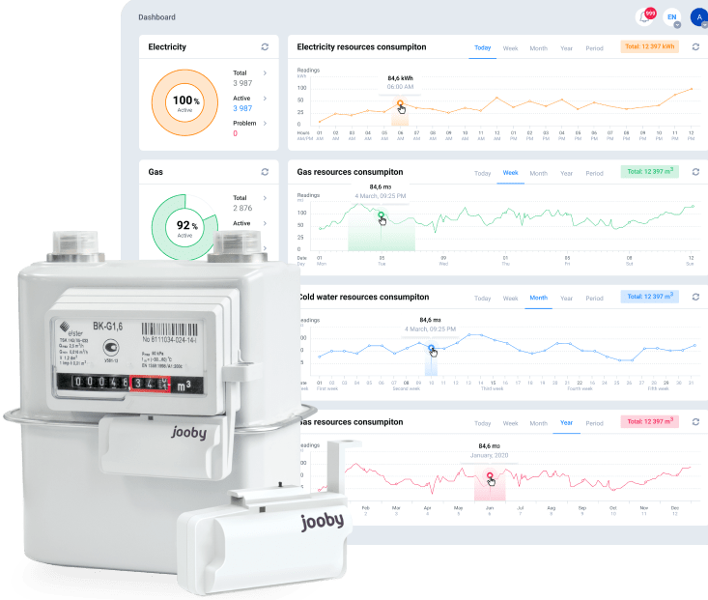Remote data collection

LoRaWAN specification. Introduction. Basic concepts and end-device classes
LoRaWAN specification. The end-devices activation
SMART street lighting  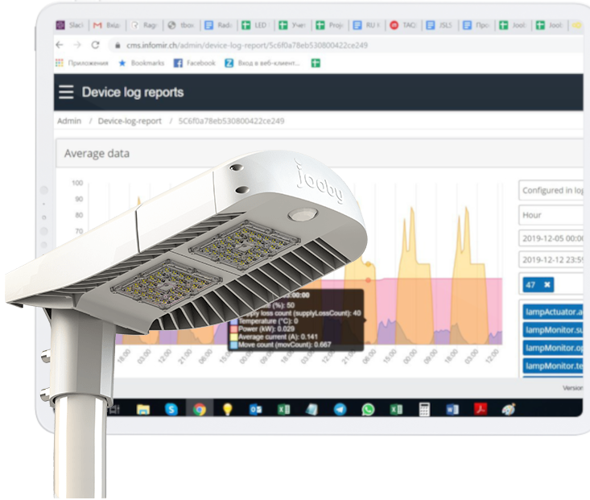Smart street lighting | Remote data collection  Remote data collection

