JOOBY MMS

Product intro
JOOBY MMS - (monitoring and management system) is an innovative product for controlling and monitoring Jooby Gateways.

Product tree
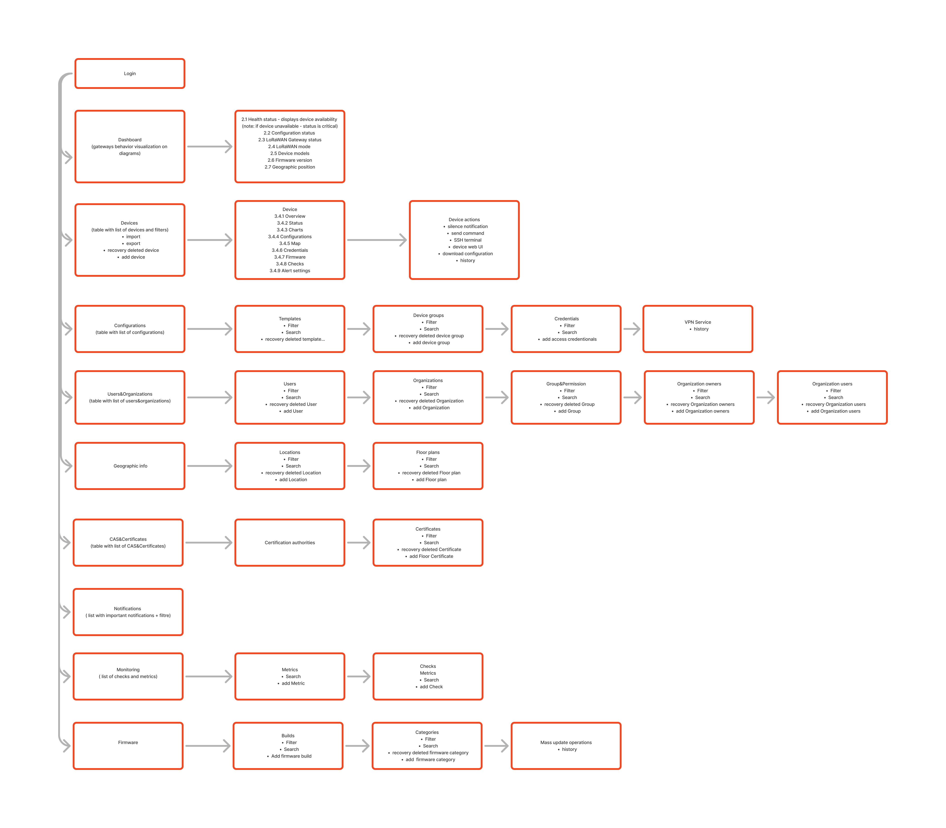

User flow

1. Login form
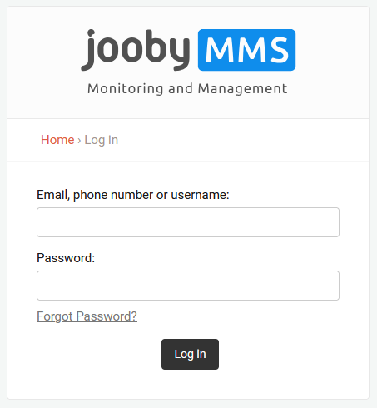

2. Dashboard
Gateways behavior visualization on diagrams
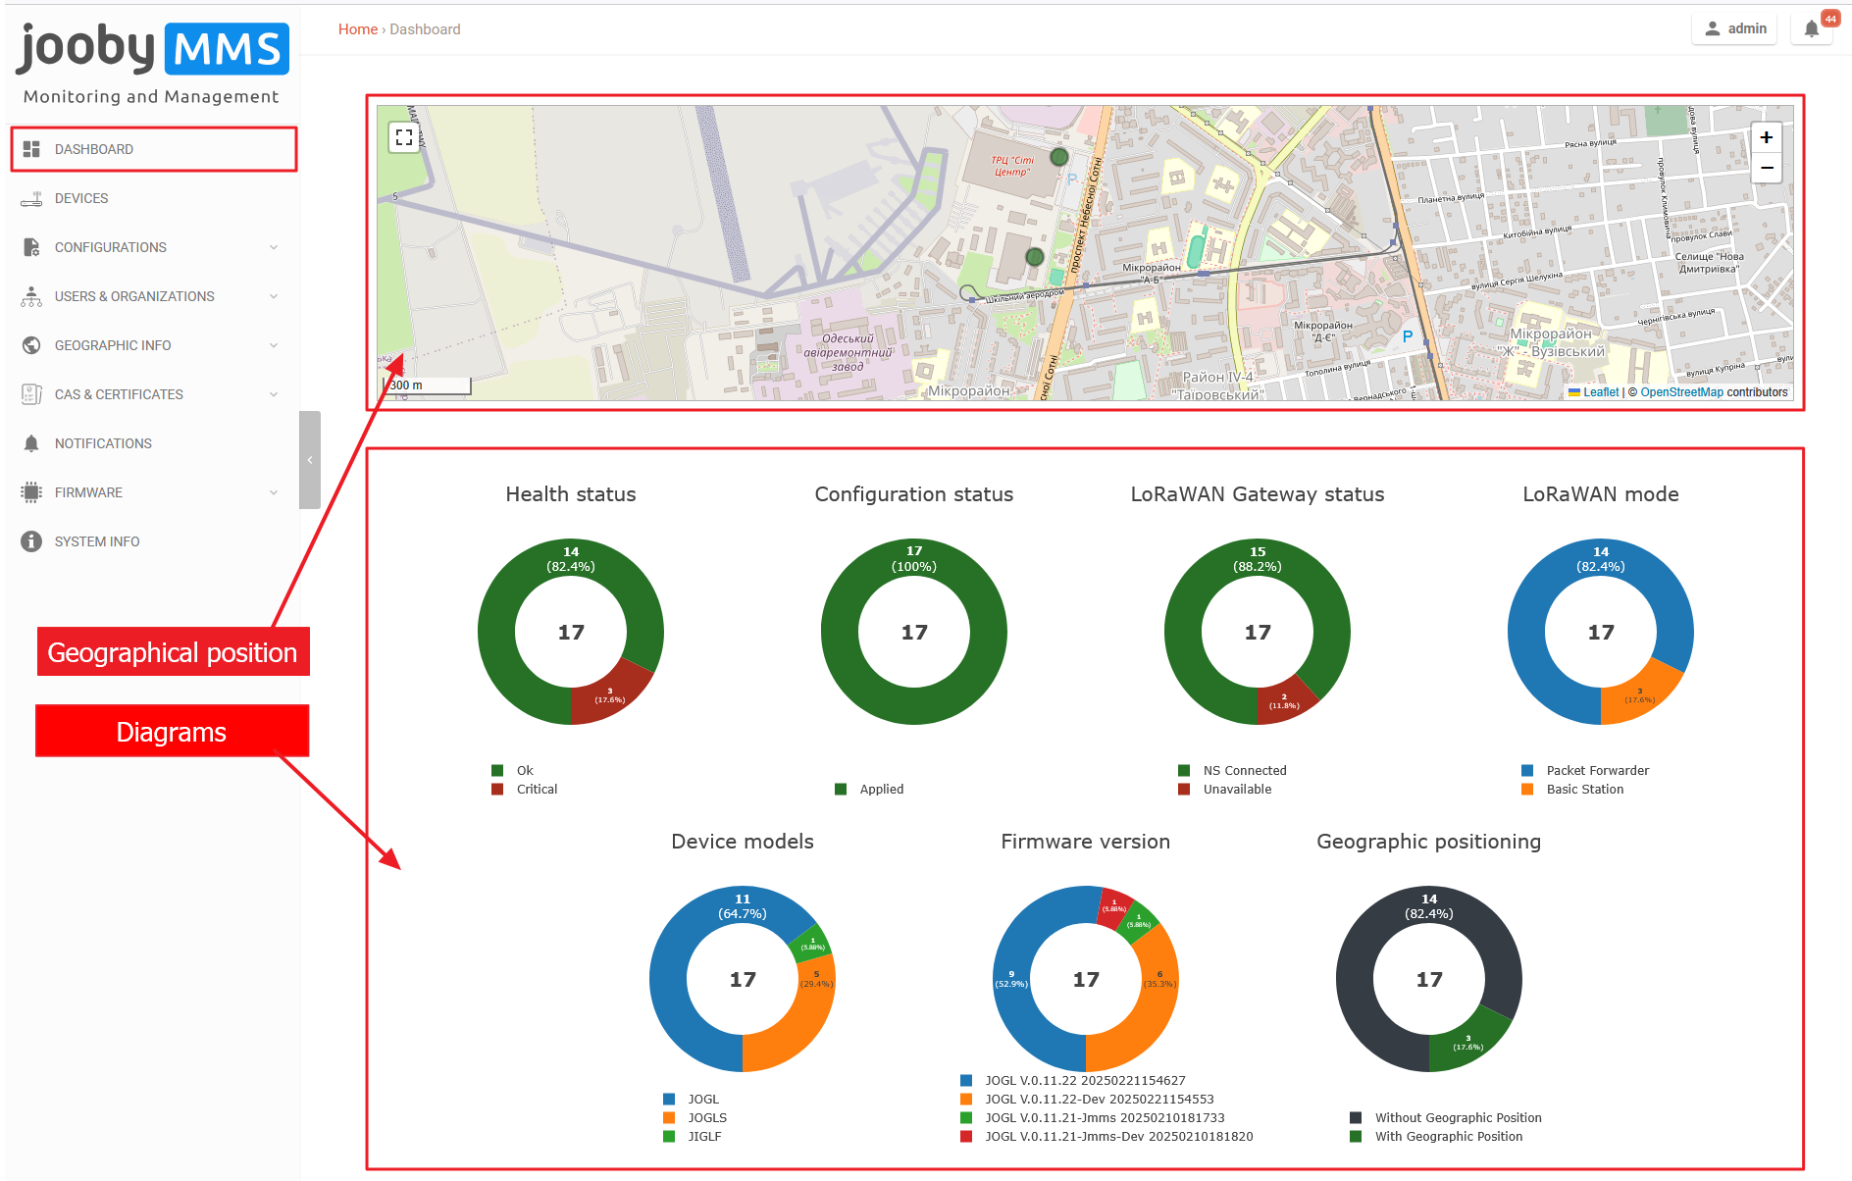
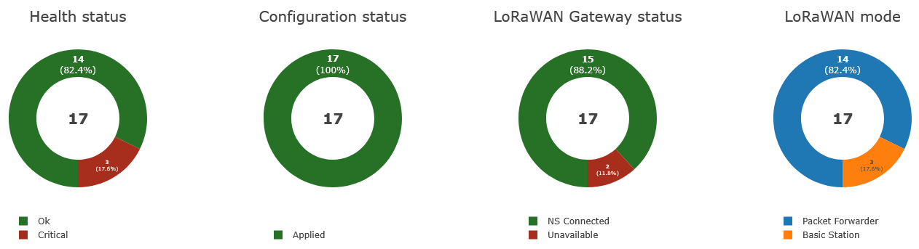
- Health status - displays device availability (note: if device unavailable - status is critical)
- Configuration status - displays the status of installing a new configuration on the device
- LoRaWAN Gateway status
- LoRaWAN mode (Packet forwarder or basic station)
Off → All modules in admin p. is off. Unavailable → not exist anyone module with 'on' state and 'available'. NS Connected → if exists any module in state 'on' + available + ns connected NS Disconnected → If not exists anyone module in (state 'on' + available + ns connected)
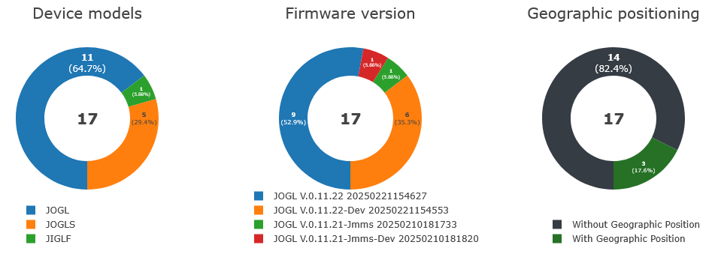
- Device models
- Firmware version
- Geographic position - displays devices with assigned geolocation and marking them on a map
All diagram sections are clickable, the user could click and the system will redirect him to the corresponding tab

3. Devices
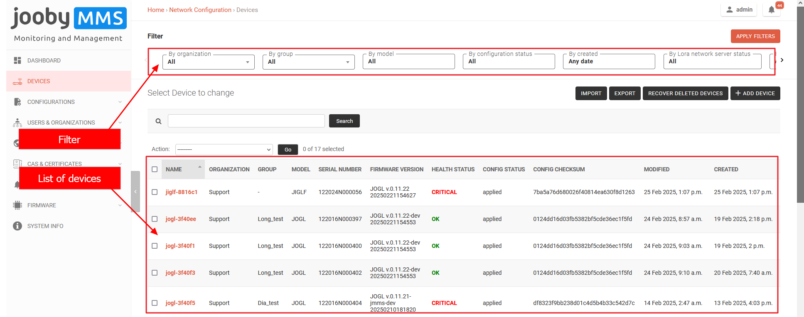
- Filter (by organization, by group, by model, by configuration status, by date created, by loRaWAN network server status, by mode, by geo position)
- List of devices
Config checksum is to understand whether the devices have the same configurations according to the selected templates or personal device config

3.1 Device adding
- via service panel
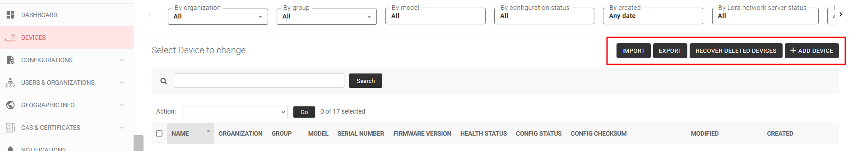
- via shared secret (copy the secret key and add it to devise settings in the admin panel)
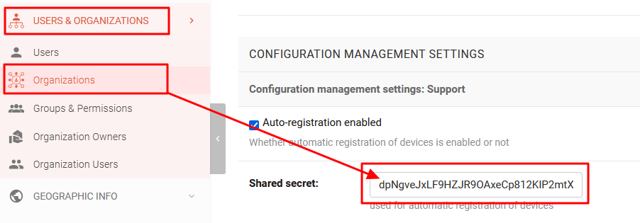
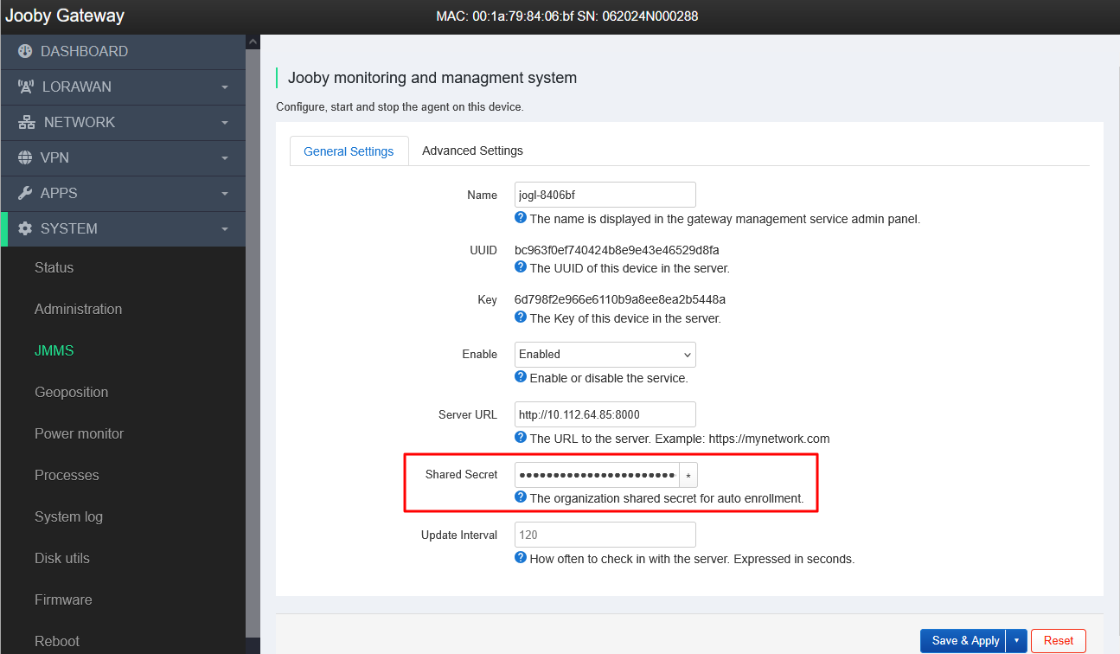
After the device receives URL and token it automatically displays at the device table

3.2 Device menu
- The user could click on any device and go into the device menu

Overview
- display all settings and configs that the device received from the admin panel and the device health check
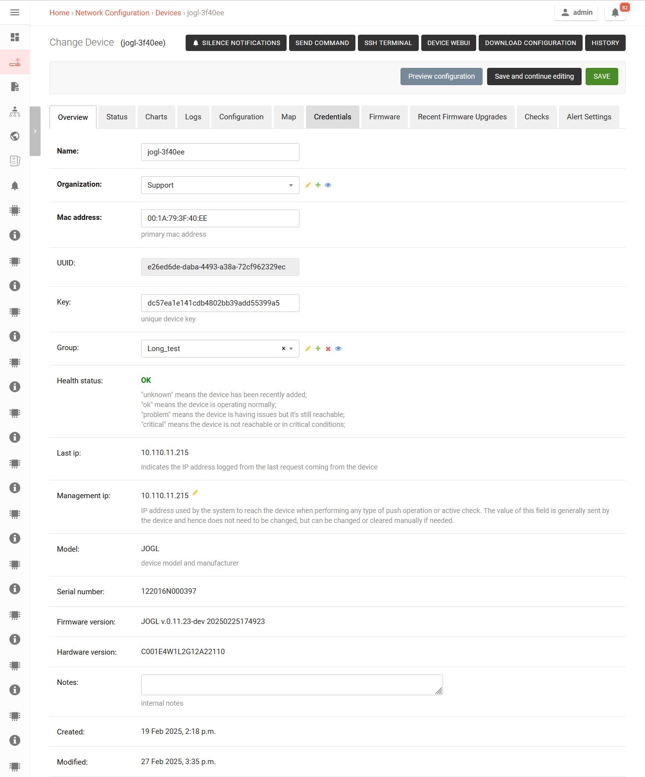
In this tab, the user can also add the device to some group

Status
- the state of the metrics that the device gives (CPU, RAM status, Storage, Interface status, Neighbors)
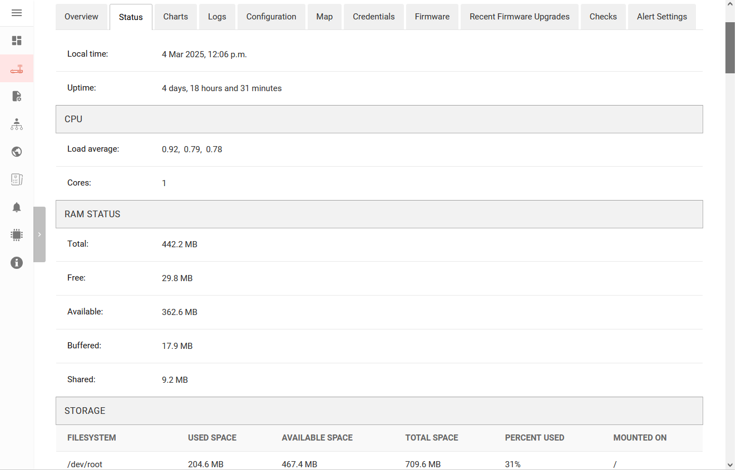

Charts
- with device statistics and monitoring (CPU usage, LoRowan uplink packages, LoRowan uplink\downlink air times, SNR, RSSI, Ping success rate, packet losts, round trip time, traffic wlan, memory usage, disk usage)
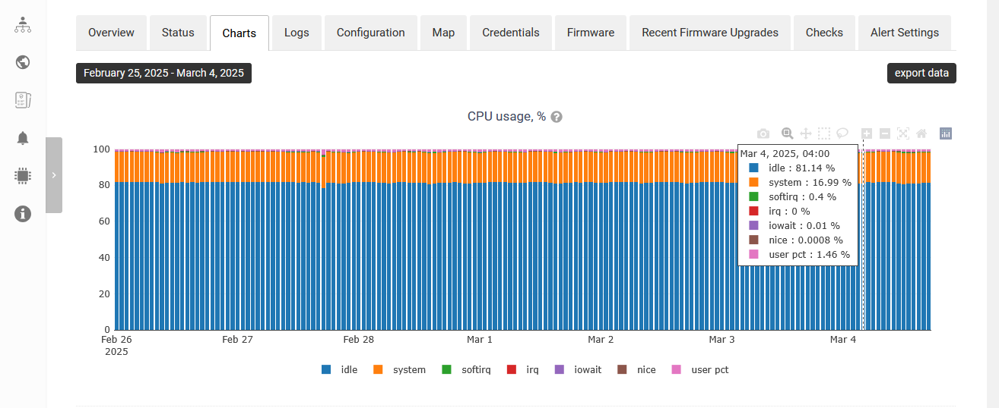
More screenshots of Device-Charts
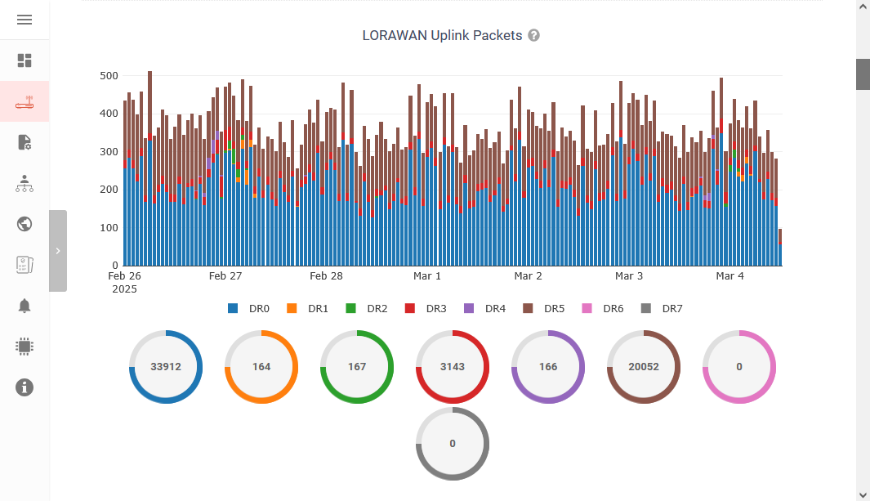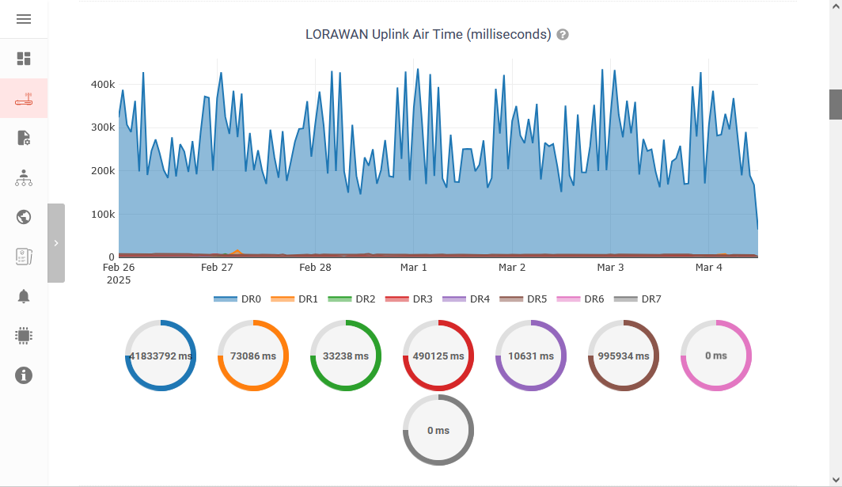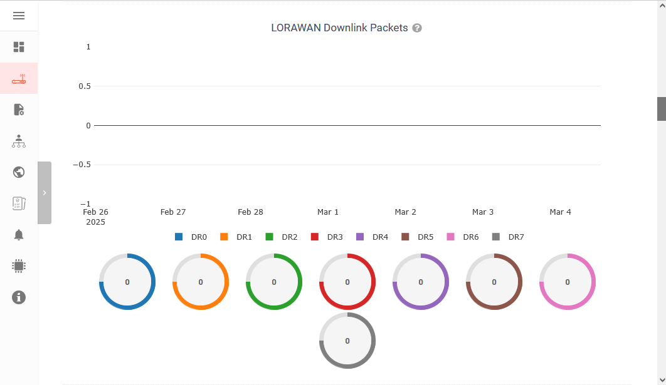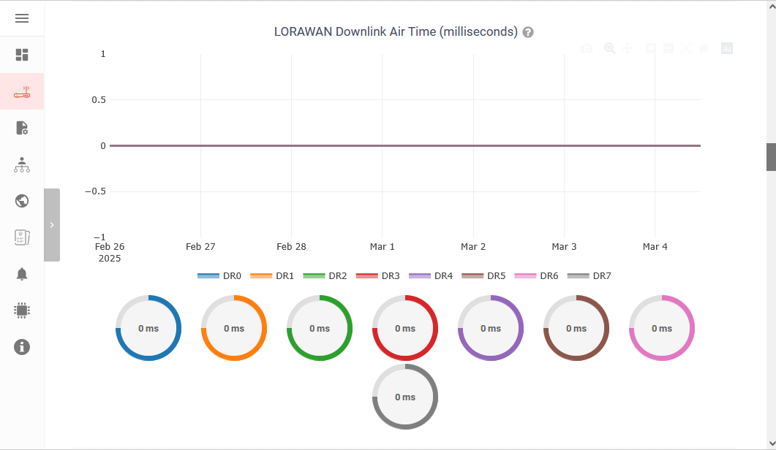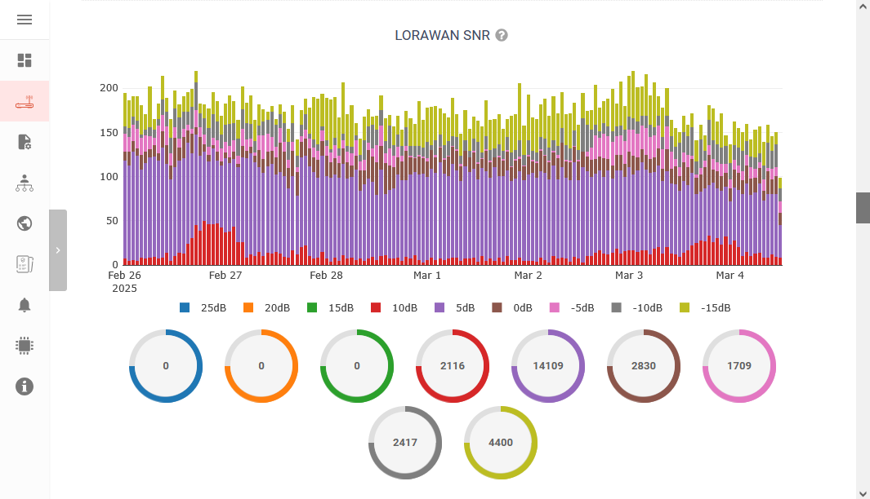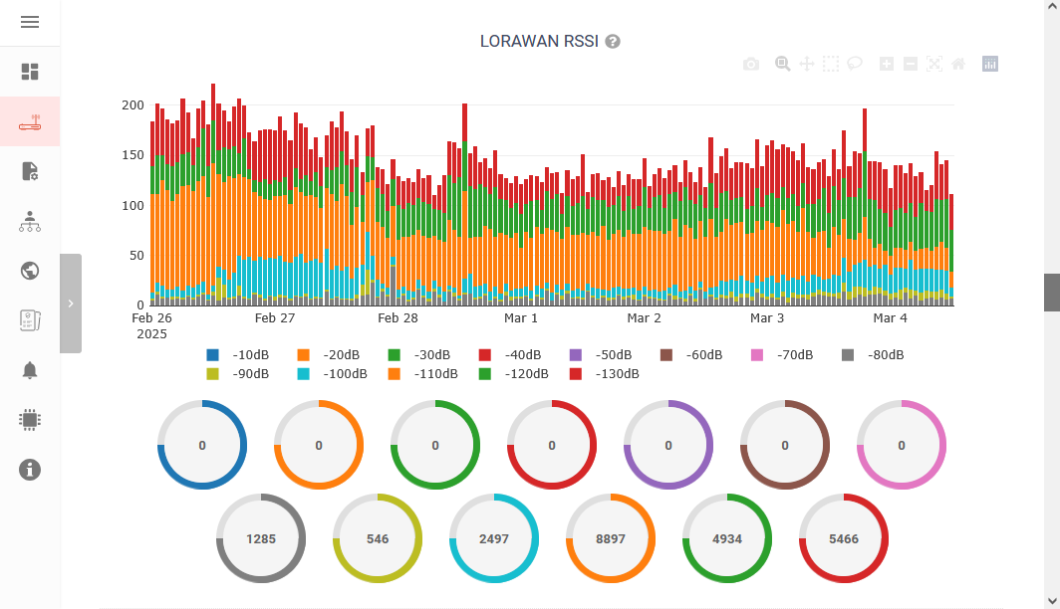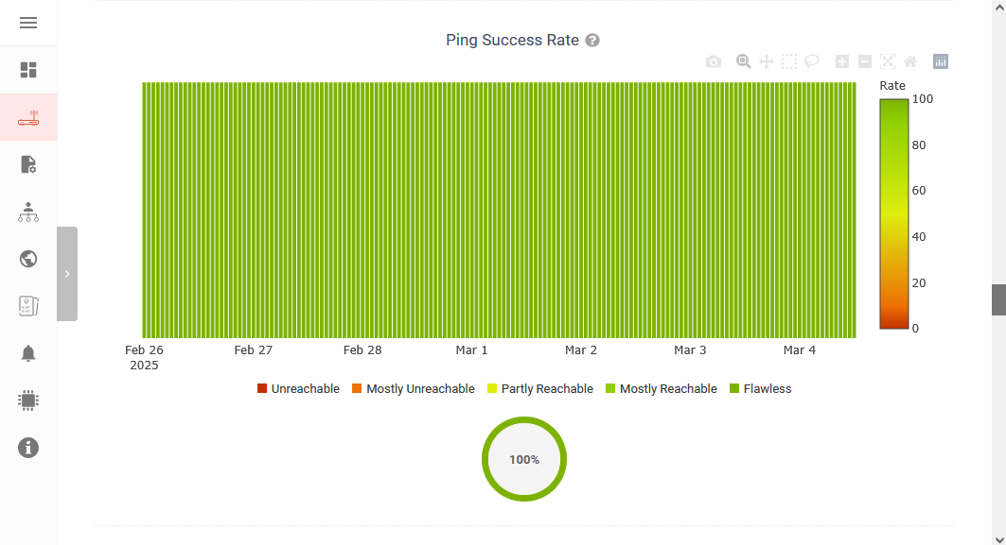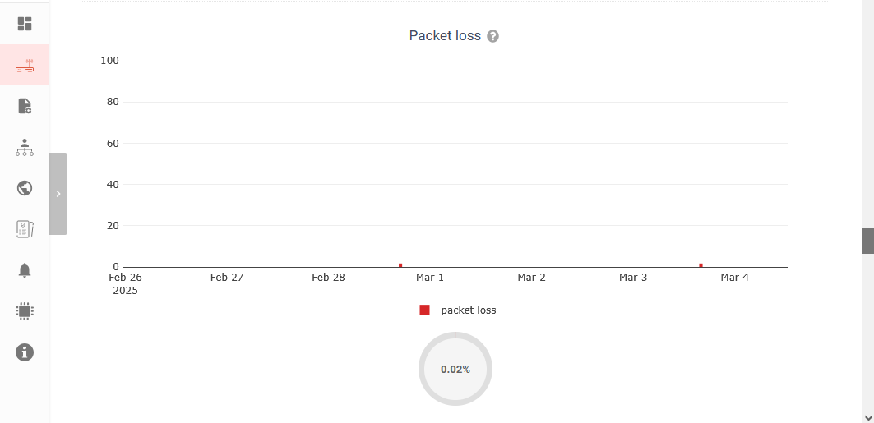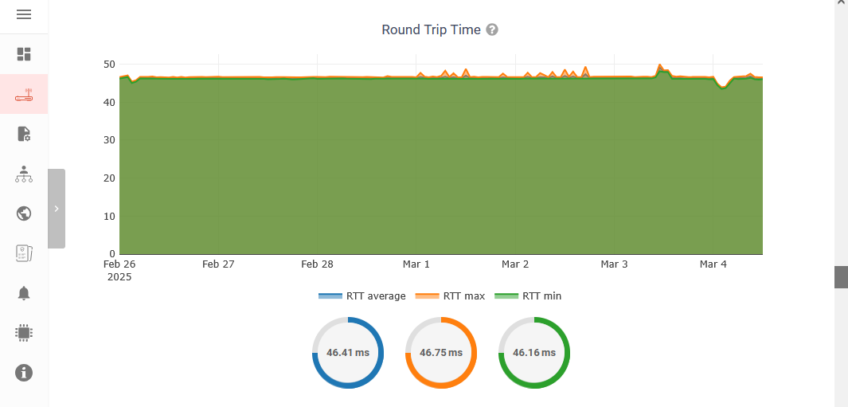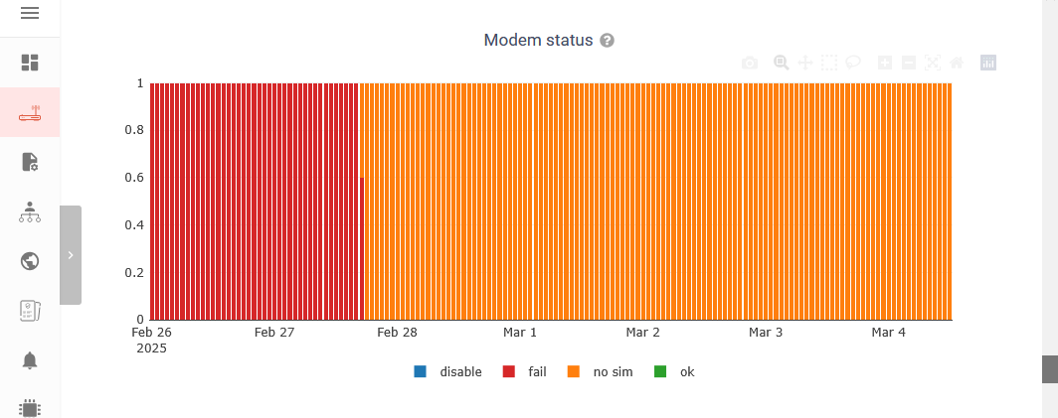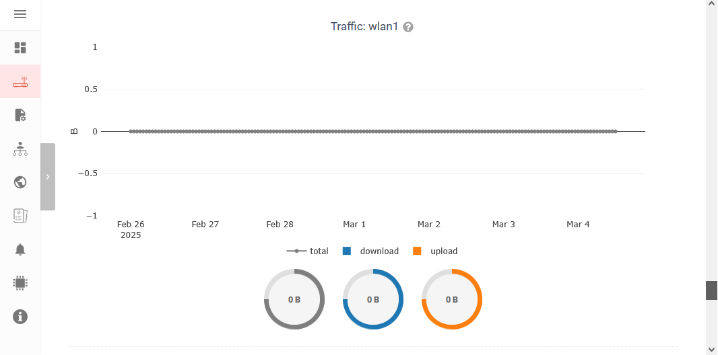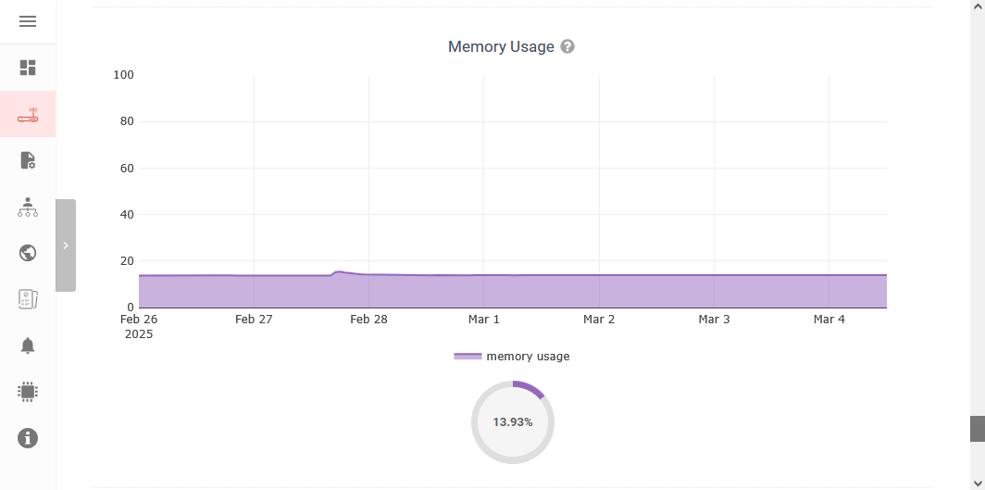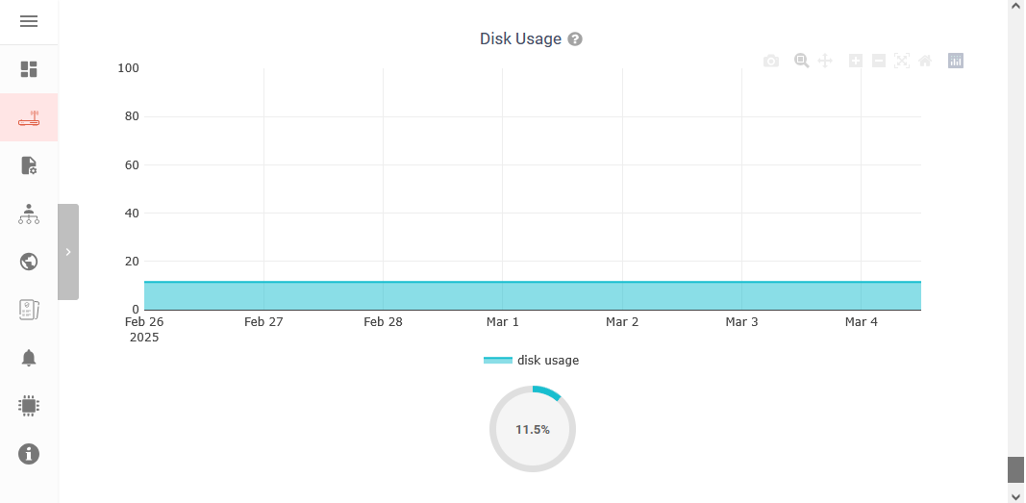

Logs
- Ability to view logs from devices (SSH, Firewall, Device manager, Kernel, Packet forwarder, Basic station, Modem manager, Network manager, NTPD, PPPD, SystemD)
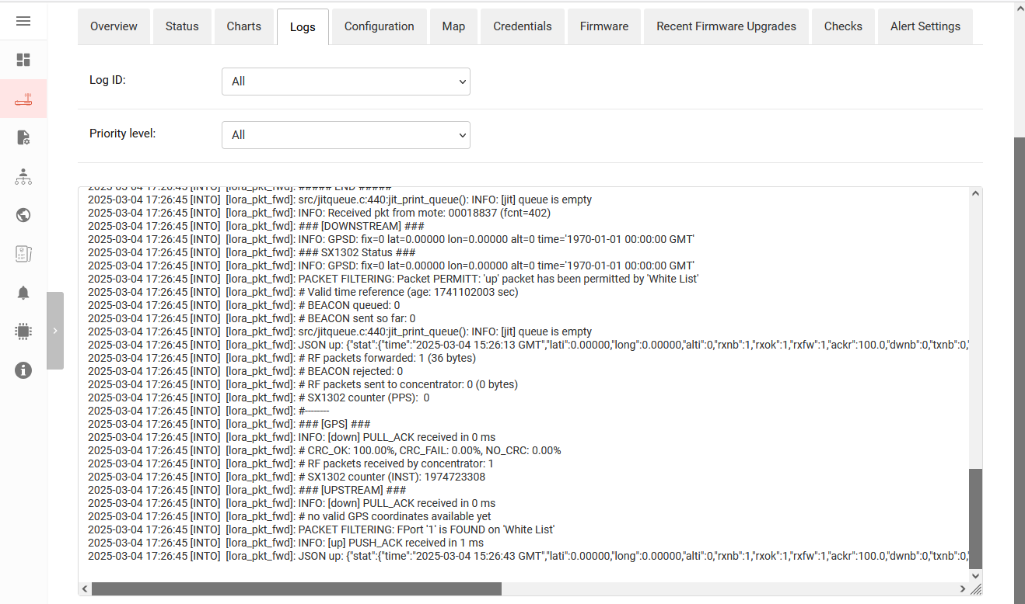

Configurations
- One of the most important features - user can add\delete any configuration
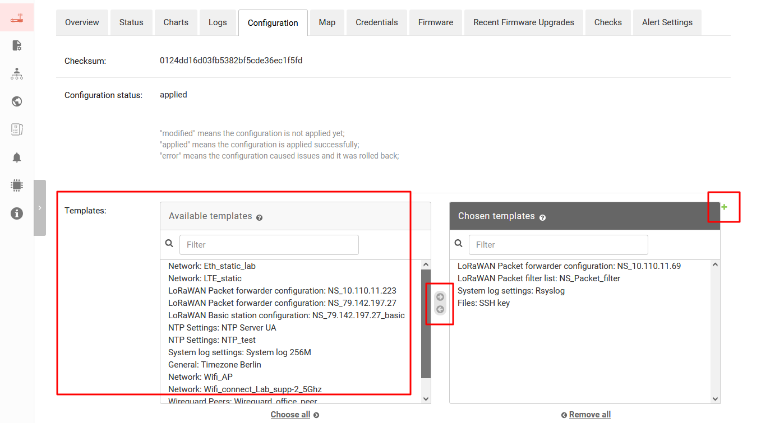
add the template as a separate menu, user can create his configuration template for future use in a group of devices or a separate device
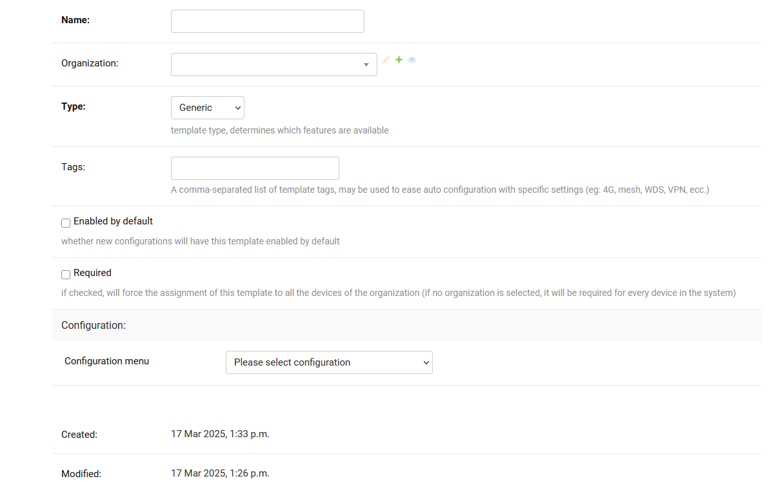
- After the user chooses a new template the program checks it and apply to the device or device group. Also user could choose already existing configurations from a list
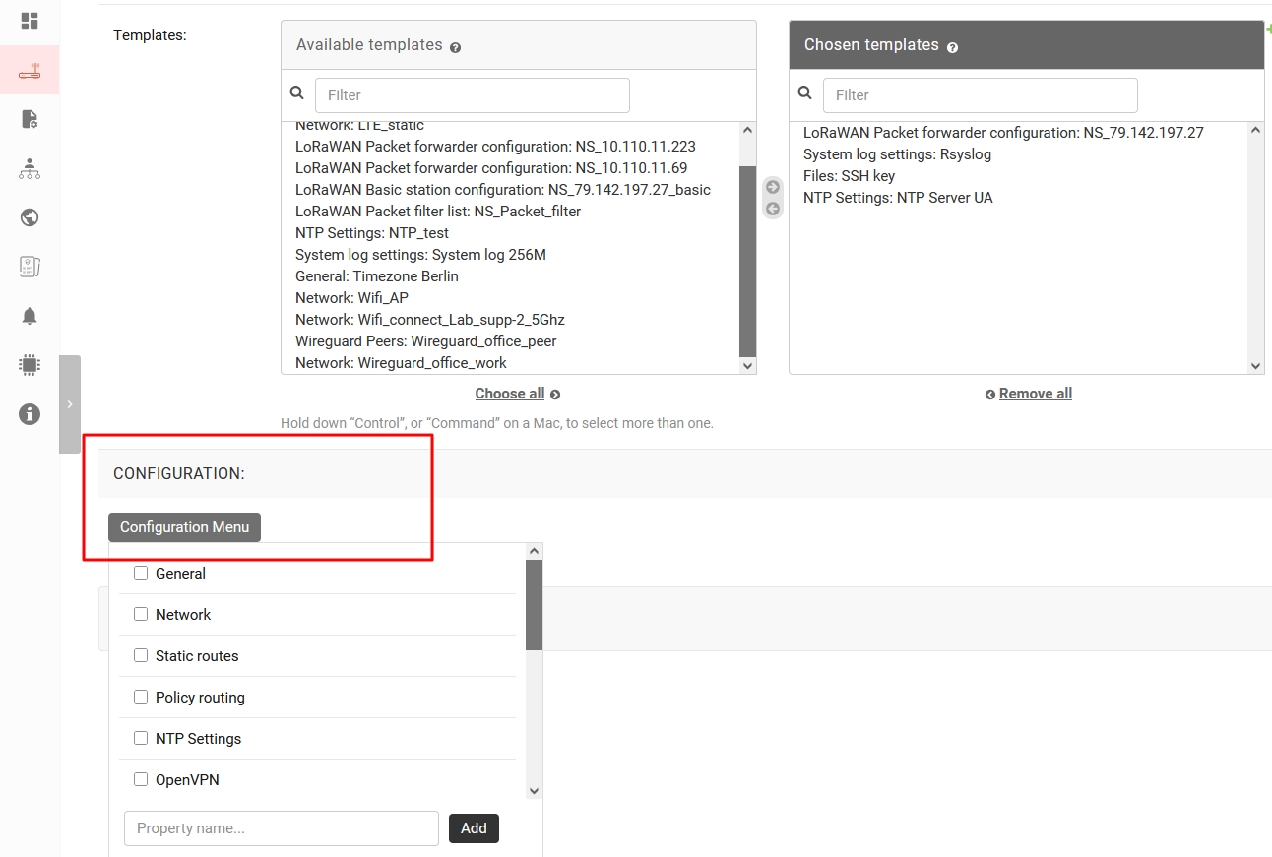

Map
- The user can choose an existing map of devices or create his own and mark the device's location
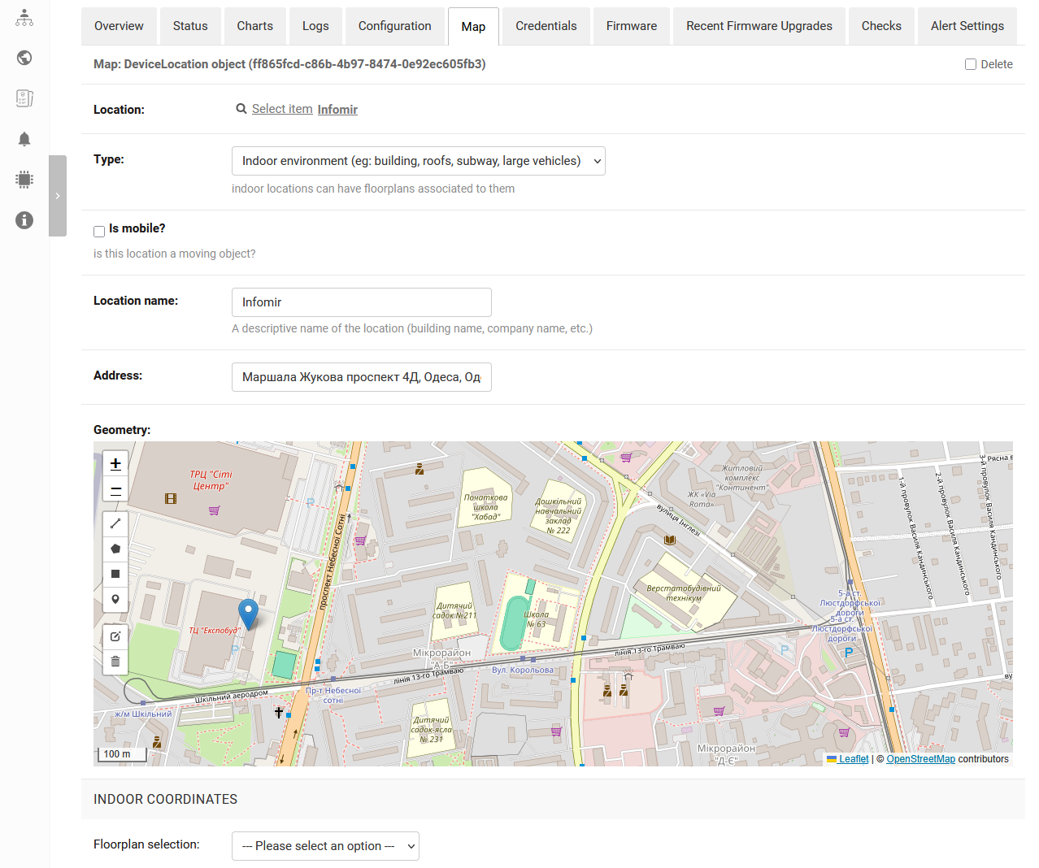

Credentials
- After adding the credentials the user can connect to device via SSH, web UI admin or send command reboot/change password (without authorization)
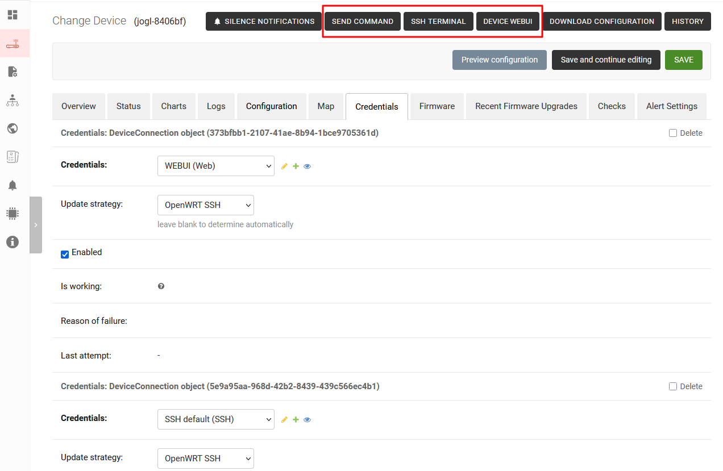

Firmware
- The user can download new firmware and update the device group or separate the device
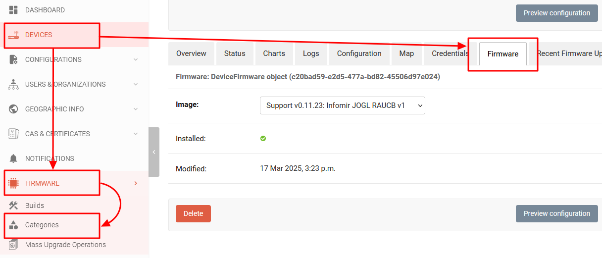
- Add the new firmware Category
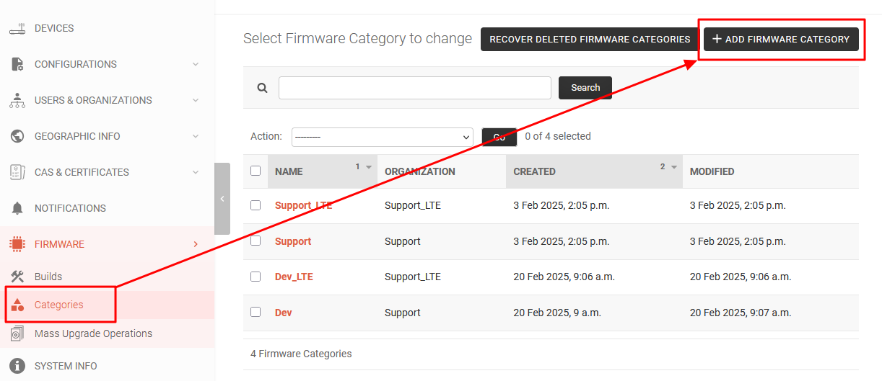
- Use tab Builds for add new or edit existing firmware build
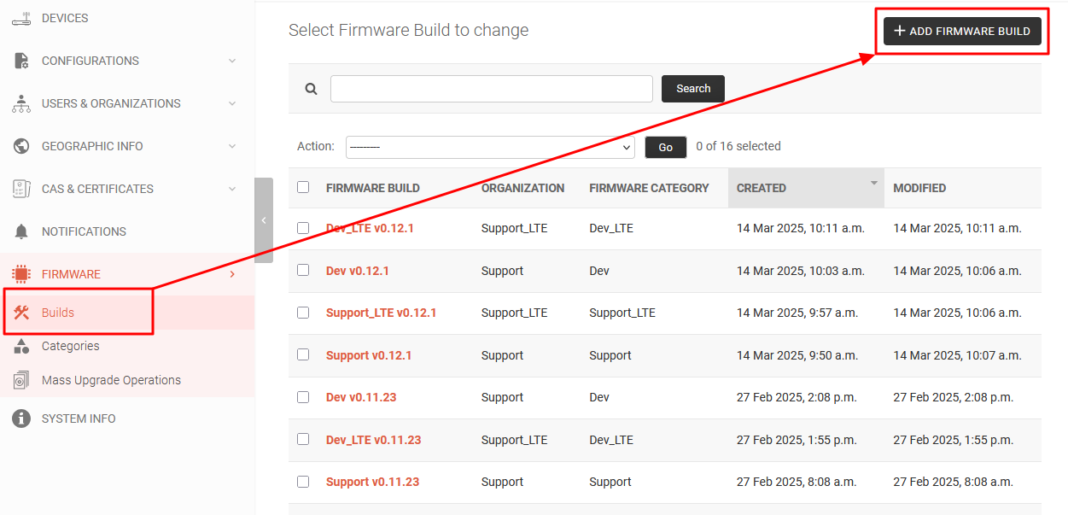

Checks - monitoring
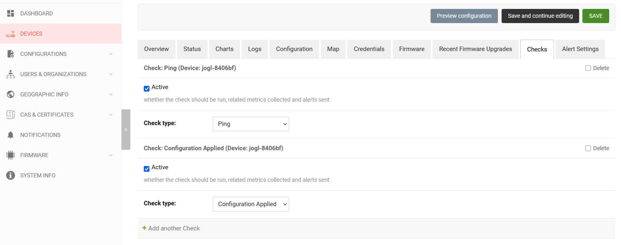

Alert Settings
- The user could set alerts that will notify the ser about unexpected behavior (for example CPU or memory usage)
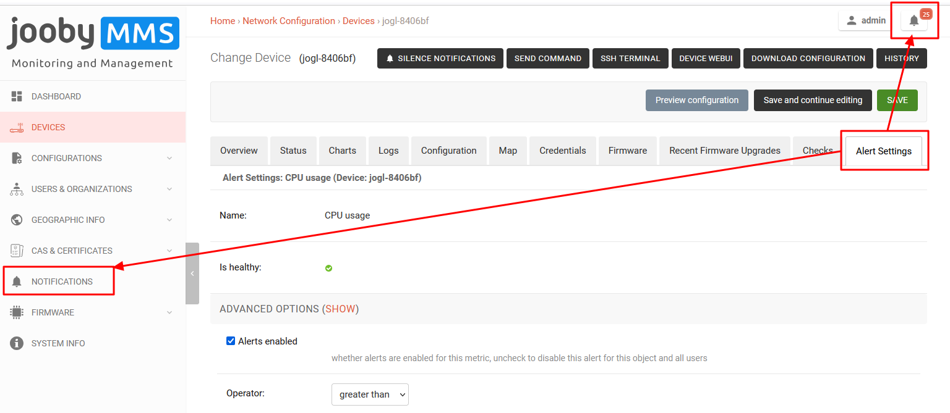

4 Configurations

4.1 Templates
- for group device configuration update ===
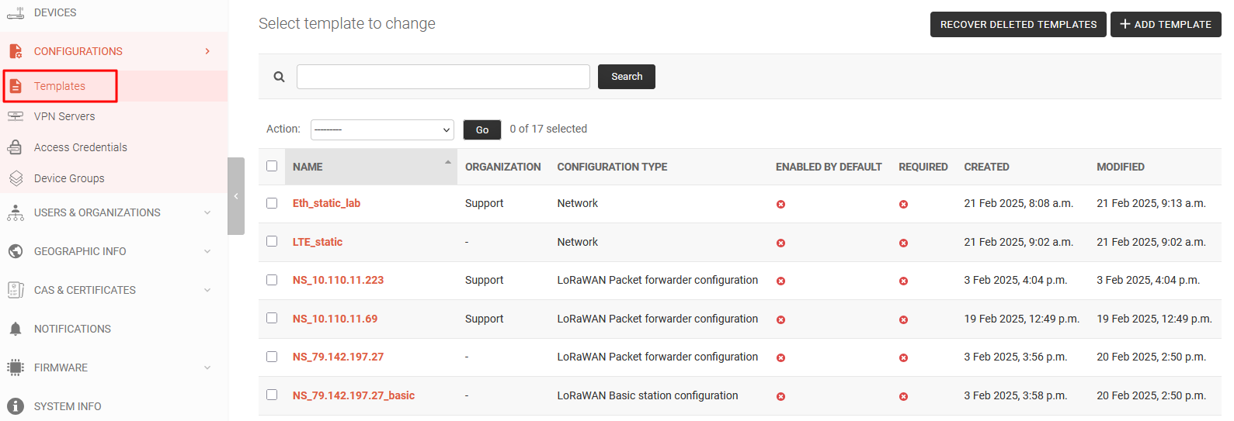

4.2 Device groups
- users could group devices via semantic feature. Choose and apply some already made or own templates for them
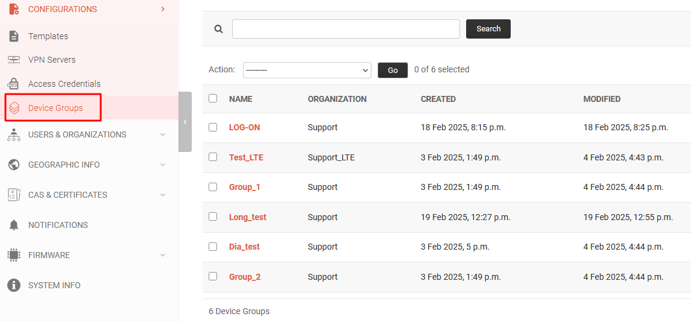

4.3 Access Credentials
* remote access from JOOBY JMMS via SSH and WEB UI
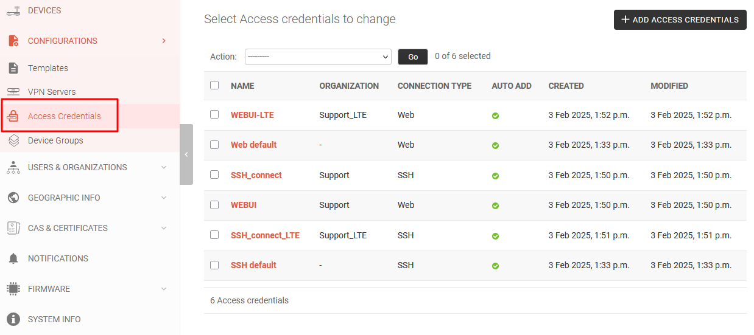

5. Users & Organizations
- Managing users, access rights, assignment to groups
- Groups&Permission - managing groups, access rights
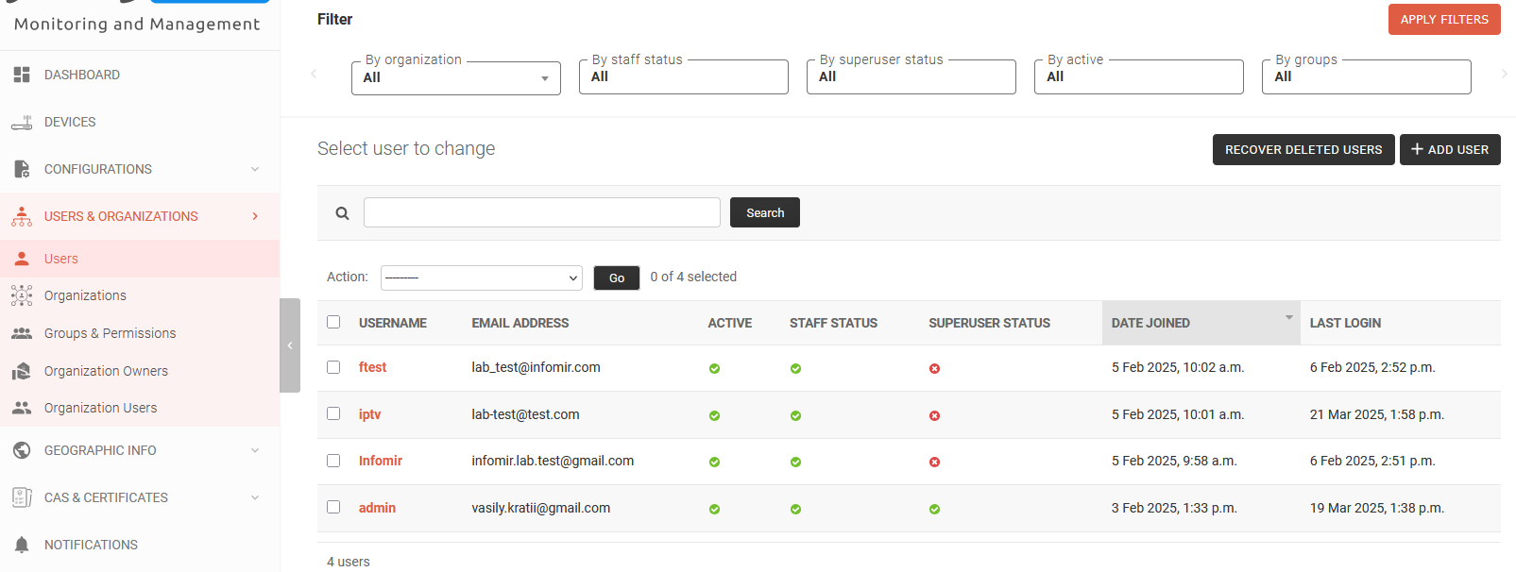

6. Geographic info
- List with locations on the map (dashboard). Users could mark devices on the map

7. CAS & Certificates
- Users could add\import certificates for working with VPN
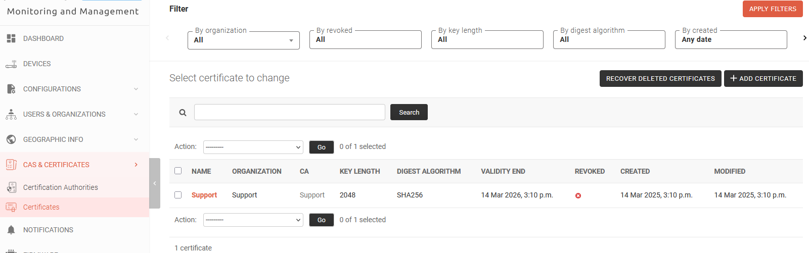

8. Notifications
- List with important notifications
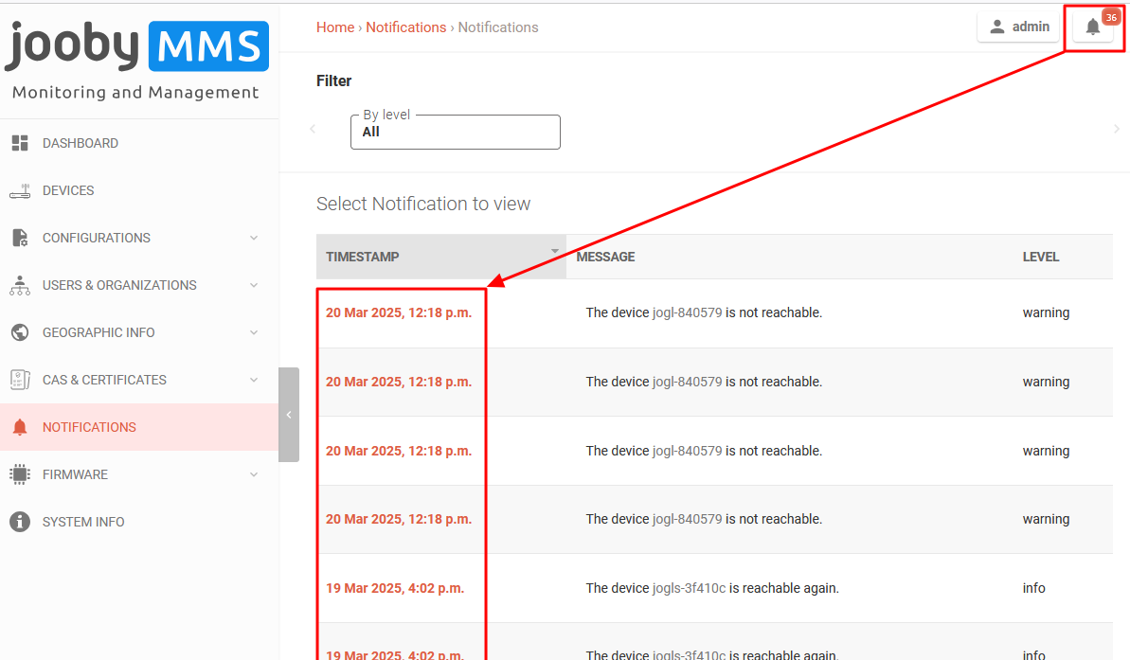

9. Monitoring
- list of checks and metrics

