Radio modules universal/multichannel (RM)  Jooby Devices  - Sensors and Cables | 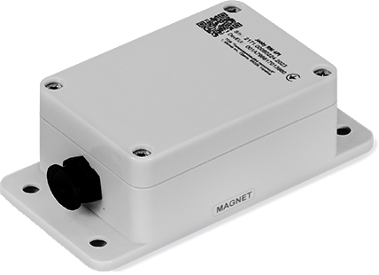

  Model | Аppearance | Resource type | Applicability | External antenna | Documentation
  Jooby OMNI RM LoRaWAN 4PU | 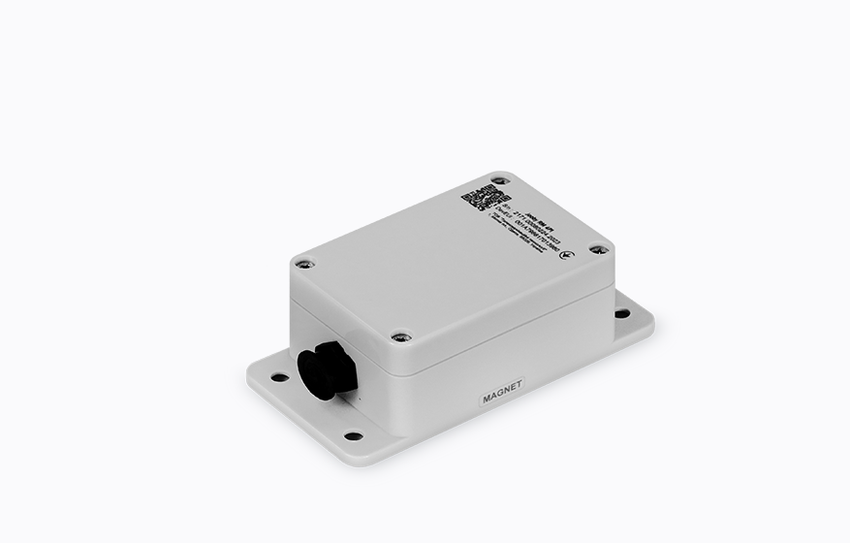 | Universal | Universal. External Sensor connection required | -
  - Description of work. Commands. Parameters
  - Command and Parameter Examples
  Jooby Development
  - API for interacting with Jobby devices. Other documentation
  - Jooby message documentation
  - Jooby message encoders/decoders
  - Jooby message encoders/decoders GUI for test

