Эта страница пока что не переведена полностью. Пожалуйста, помогите завершить перевод.
(Сотрите это сообщение по окончании перевода.)
  Jooby Devices
  - Radio modules universal/multichannel (RM)
  - Sensors and Cables
  Jooby Development
  - API for interacting with Jobby devices. Other documentation
  - Jooby message documentation
  - Jooby message encoders/decoders
  - Jooby message encoders/decoders GUI for test

RM 4PU/4PI Radio Module - Installation/Activation
- Description of work. Commands. Parameters
- Command and Parameter Examples
- Connect the Sensor cable connector to Jooby Splitter 1x4PU/1x2PU and fix with nuts (Fig.1-2-3).
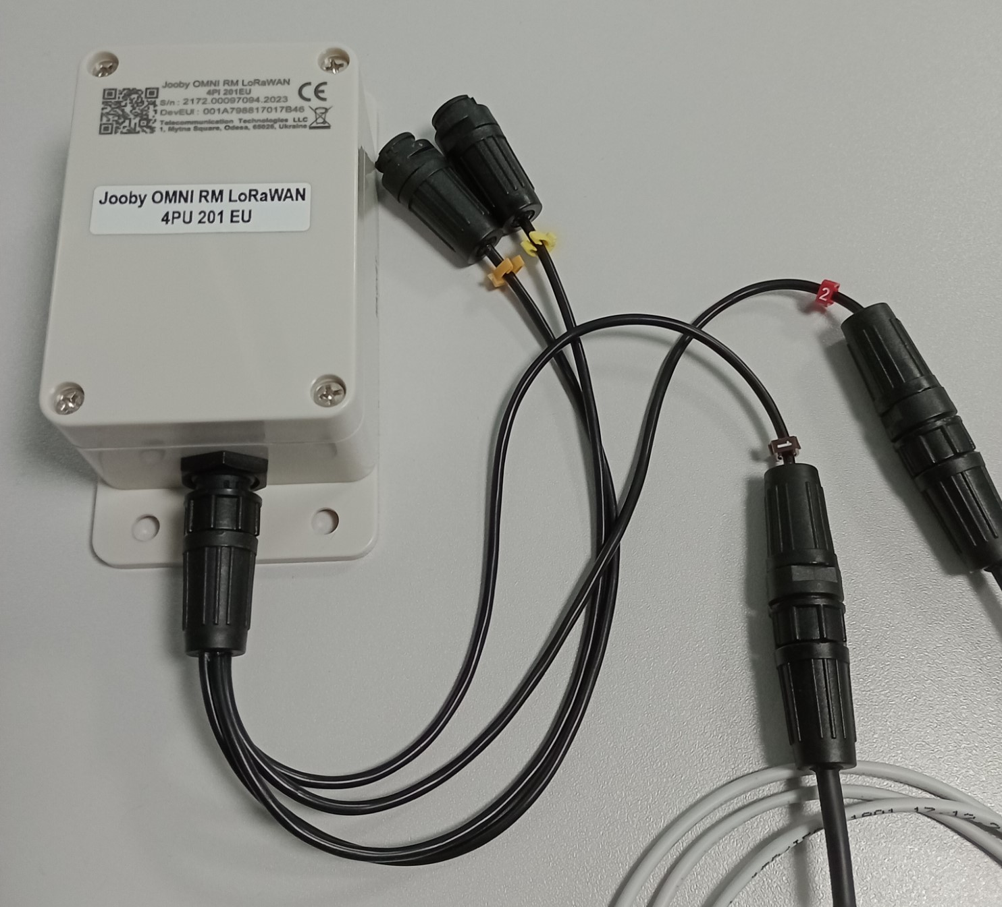
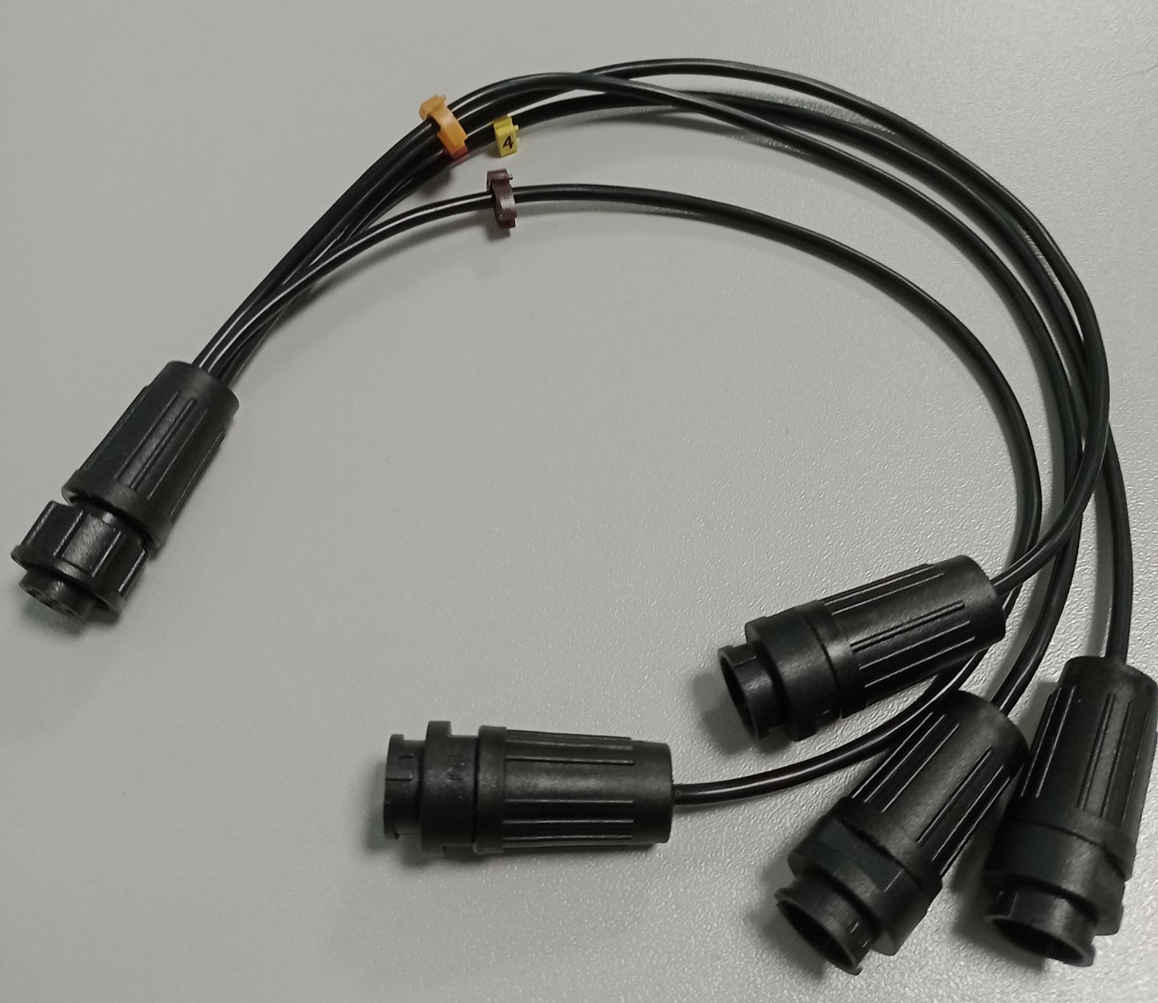Fig.1
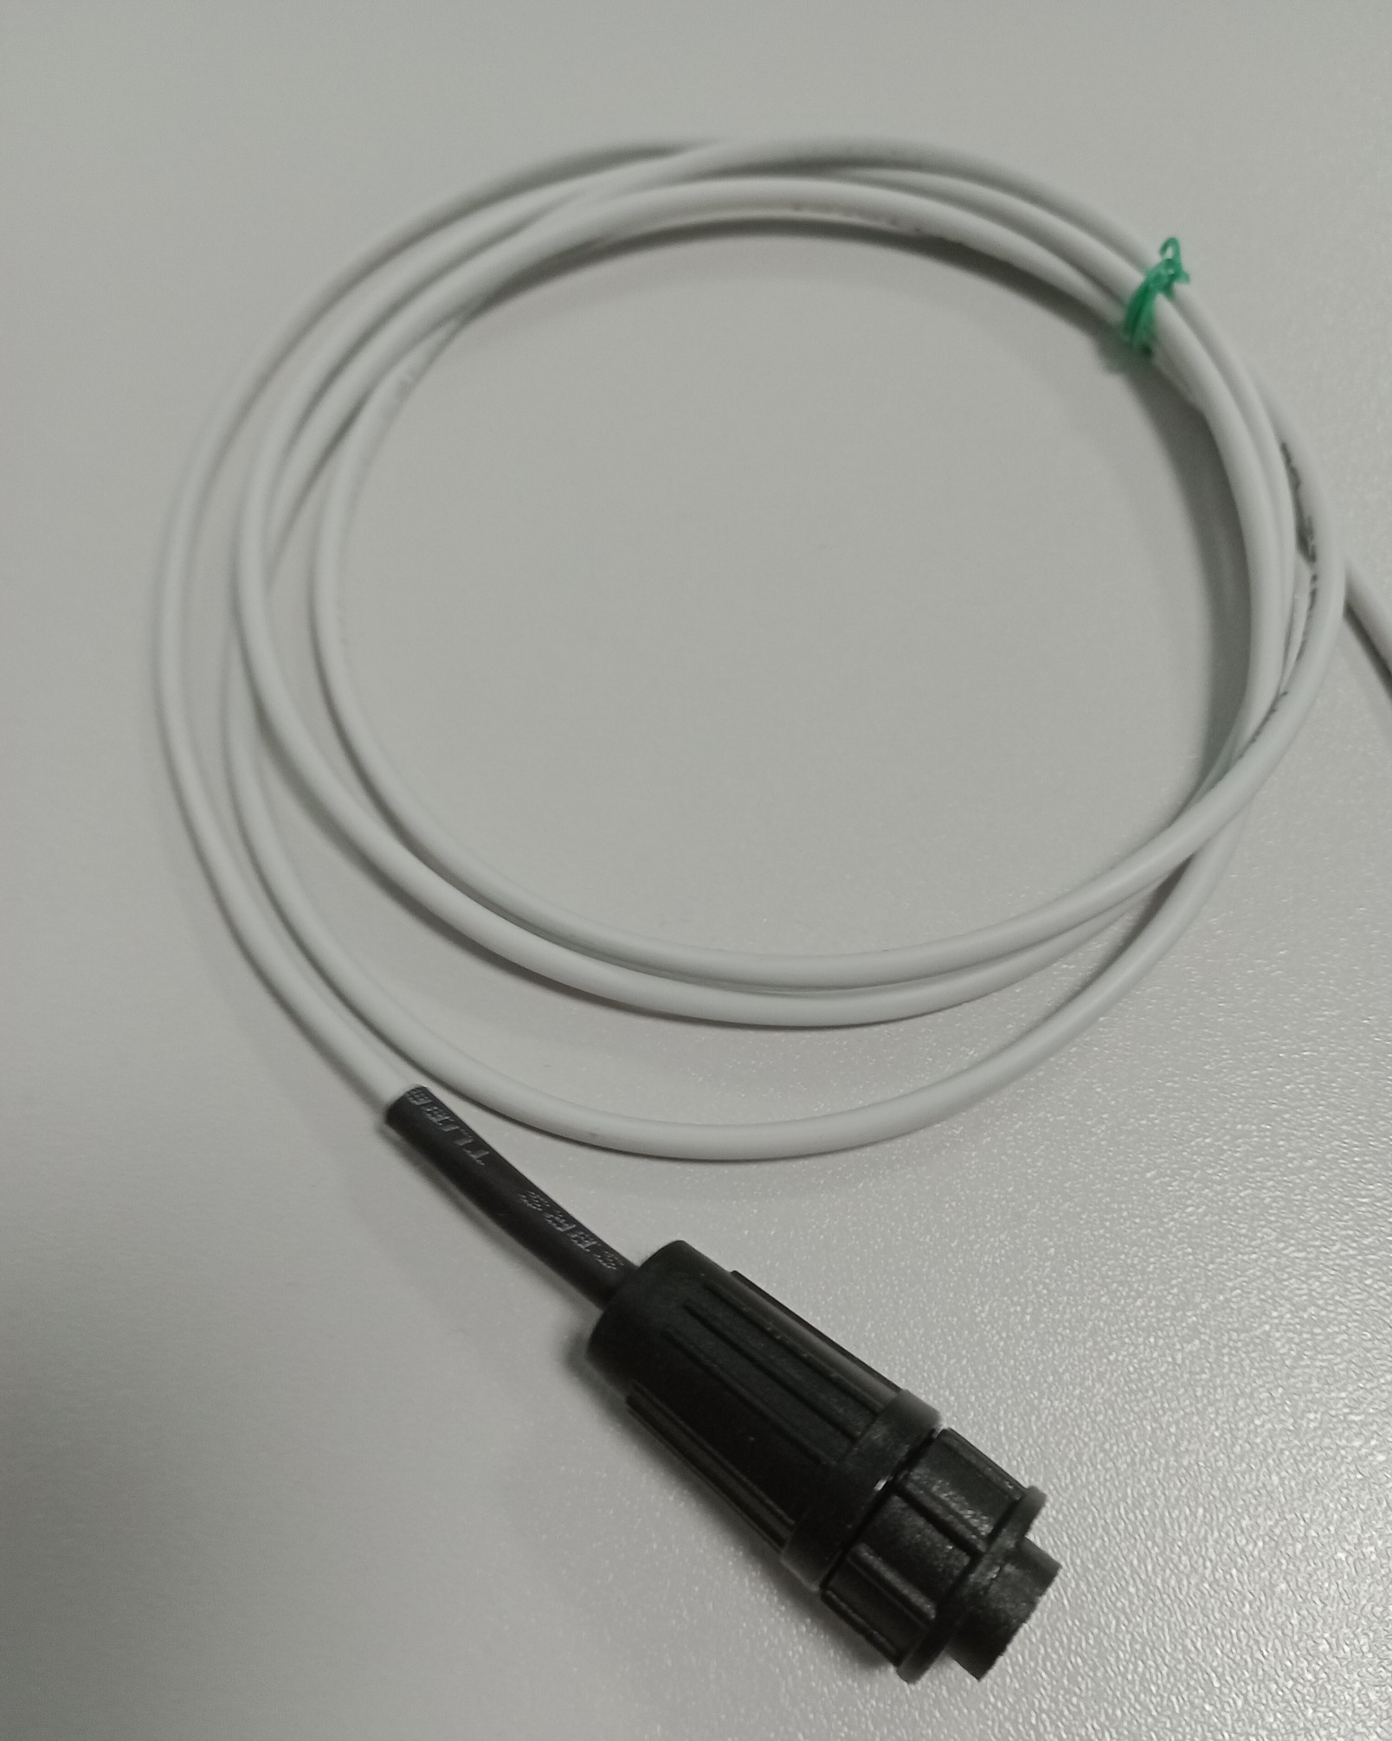Fig.2
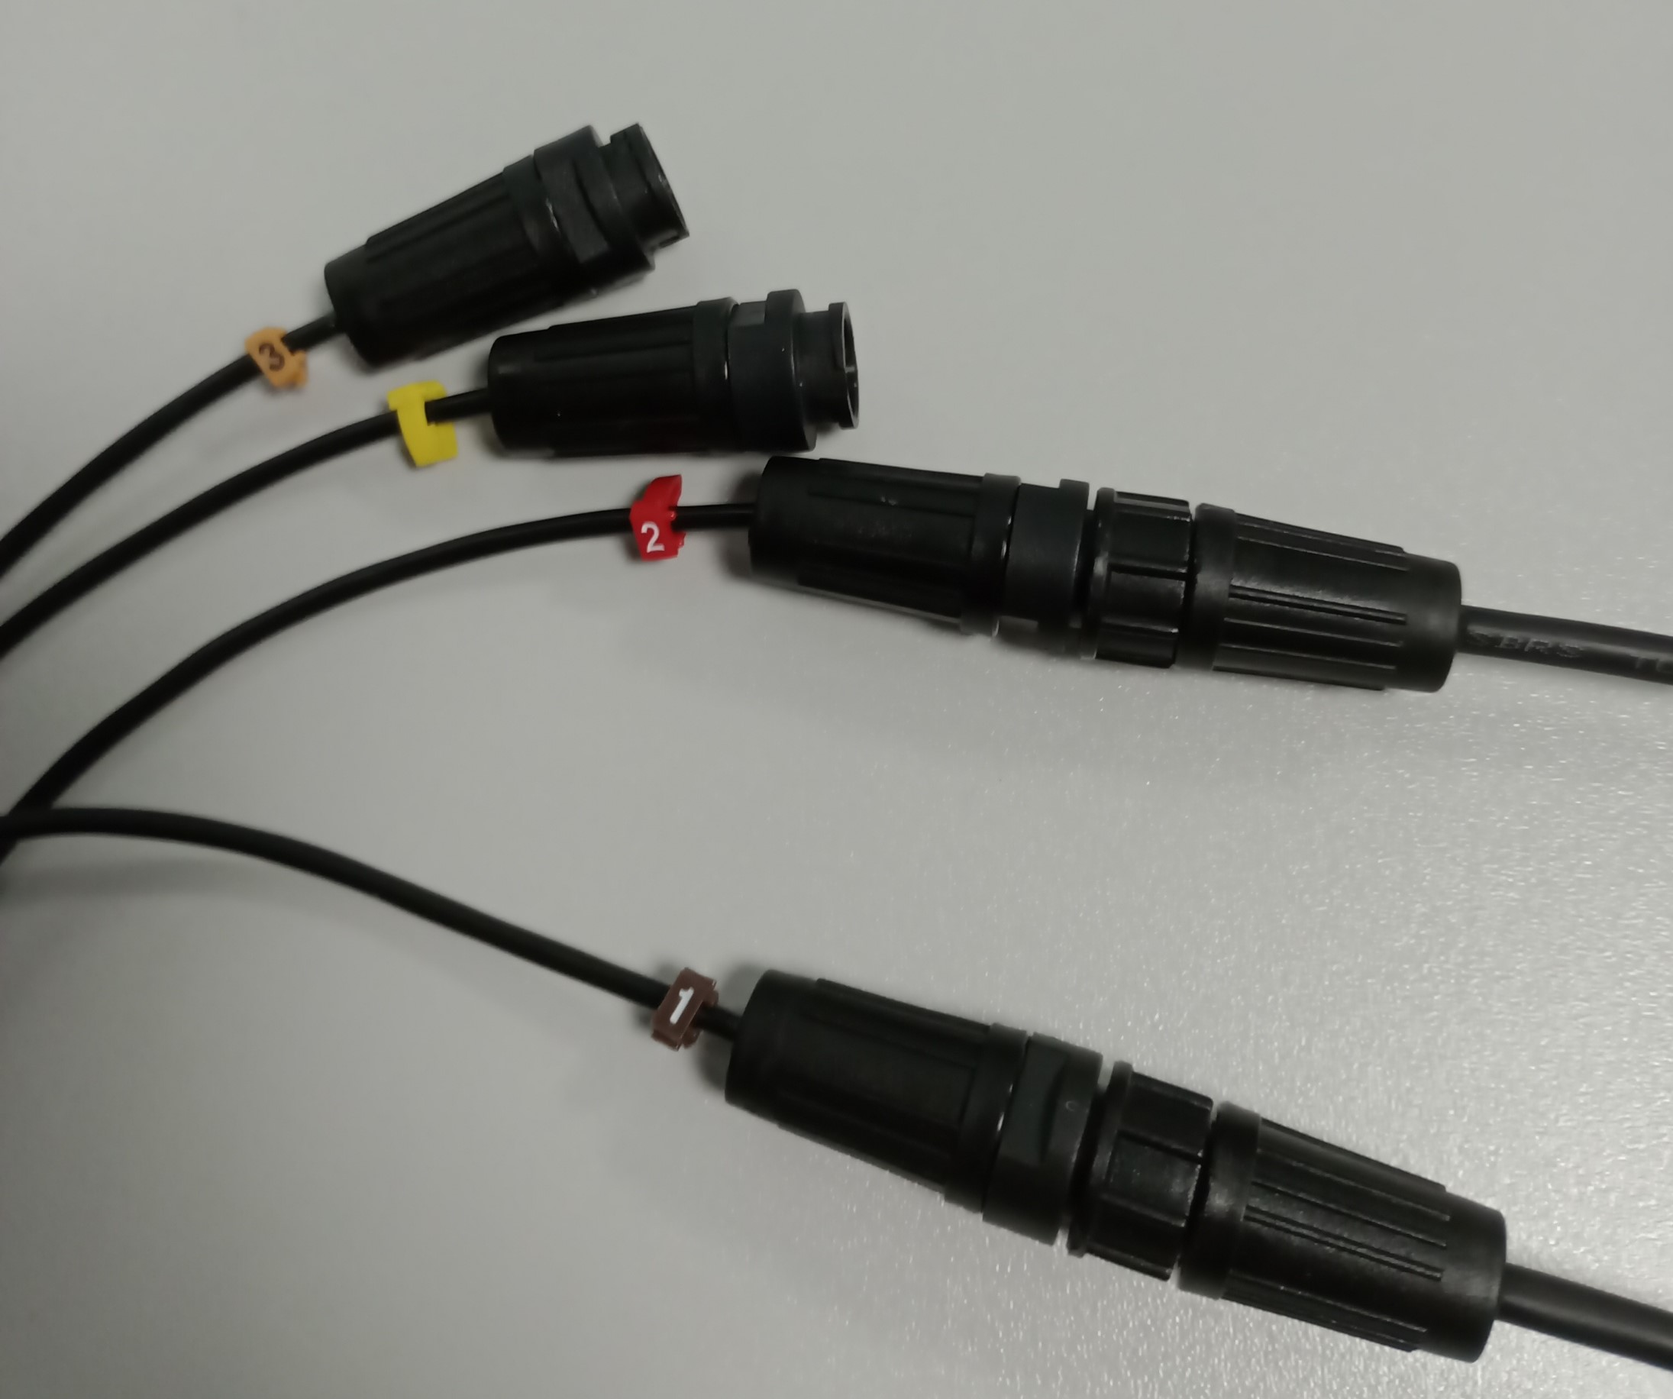Fig.3
Attention! On the Jooby Splitter 1x4PU/1x2PU cable there are clips indicating the port number of the Radio Module (Fig.4).

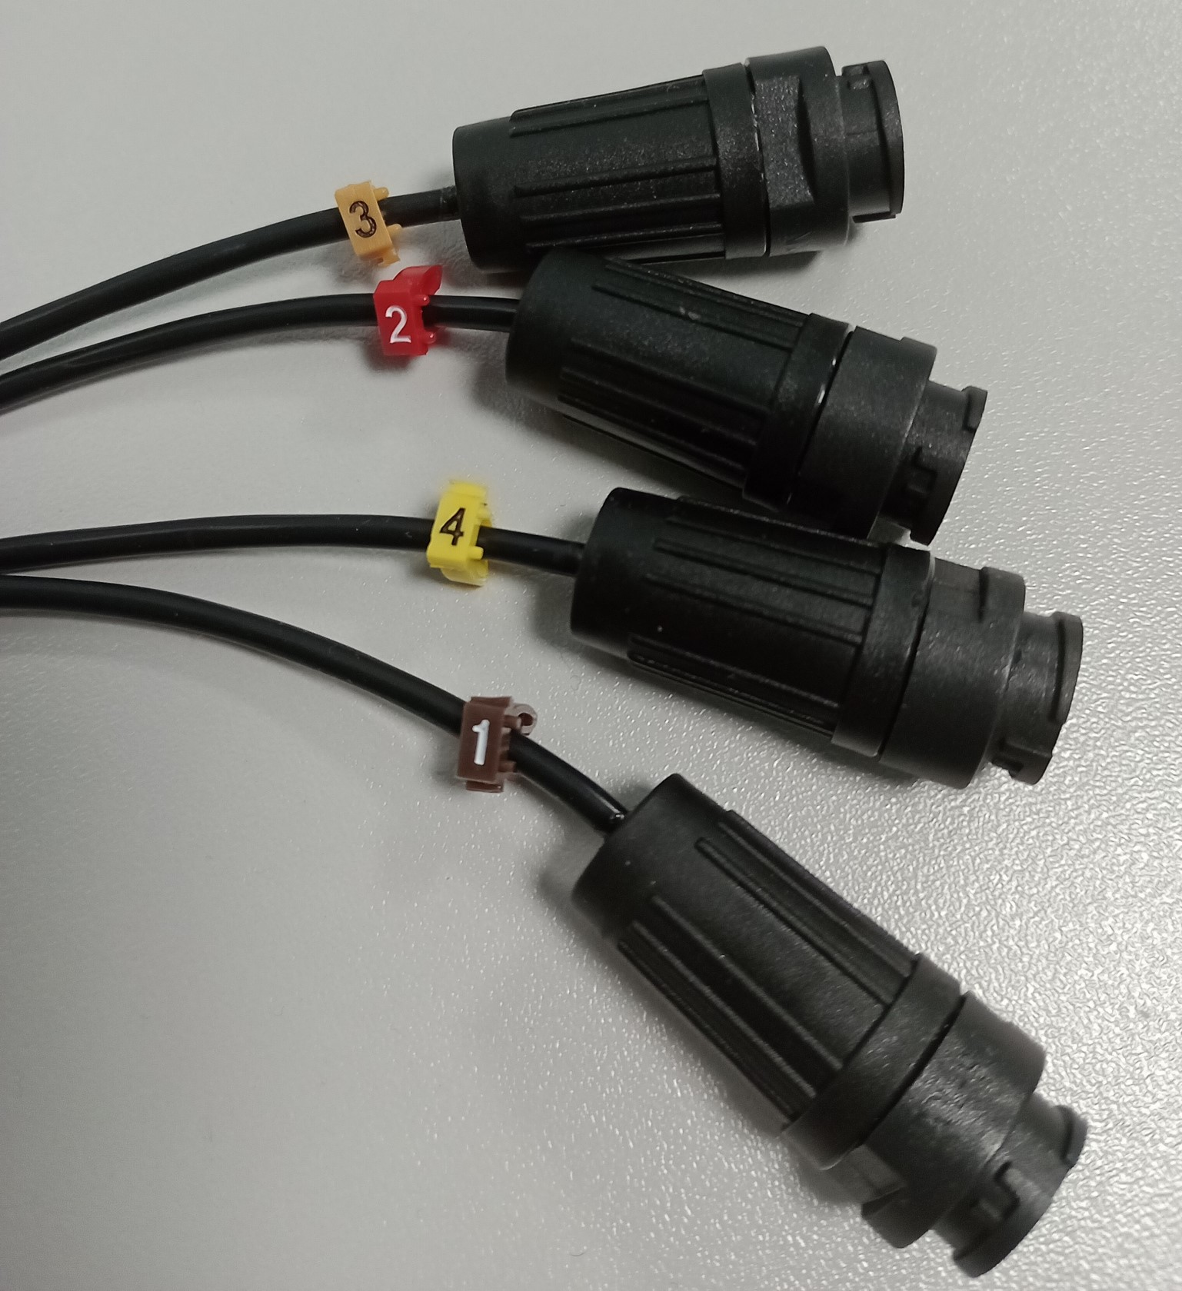
- Activation. Connect the connector of the 4-port cable to the Radio Module and fix it with the nut (Fig.5). When the connector is connected to the Radio Module, an Activation event is generated. To reactivate module, disconnect and connect again the 4-port cable connector to the Radio Module.
- Optional! Forced sending of the current values of the pulse counter on all ports. Bring the magnet for a few seconds to the body of the Radio Module in the designated area (Fig.6).
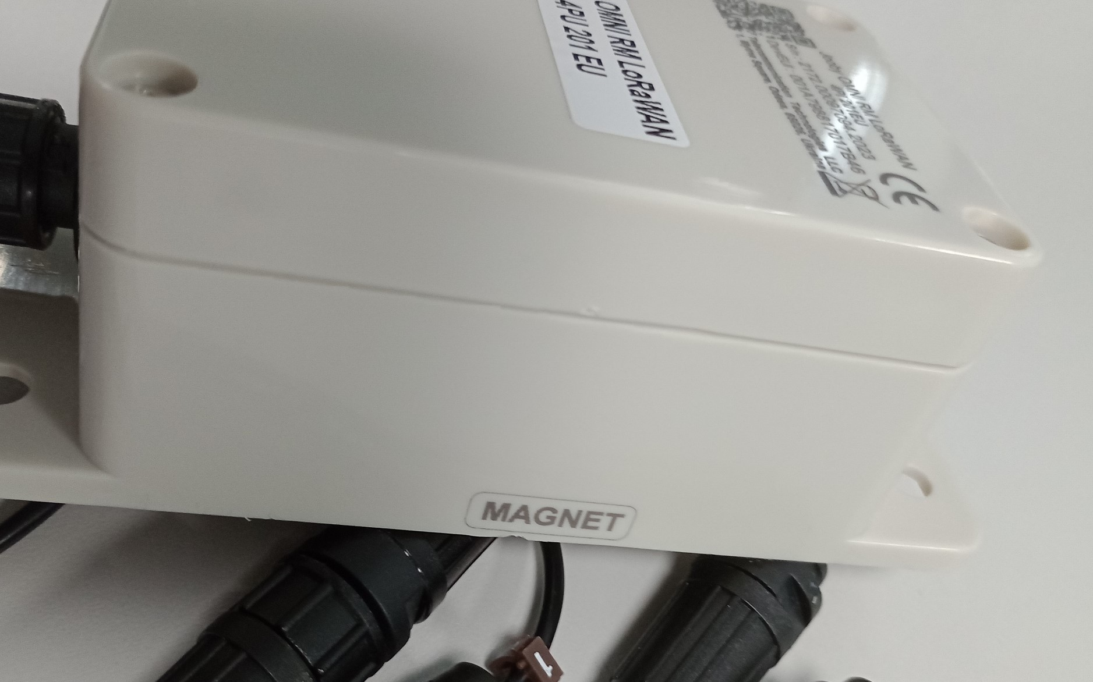
After the magnet is applied, the Radio Module will send the current value of the pulse counter to all ports.

