Water Accounting  Jooby Devices  - Ultrasonic water meter JOOBY JWM  - Radio modules with sensor (RMS)  - Radio modules universal/multichannel (RM)  - Sensors and Cables | 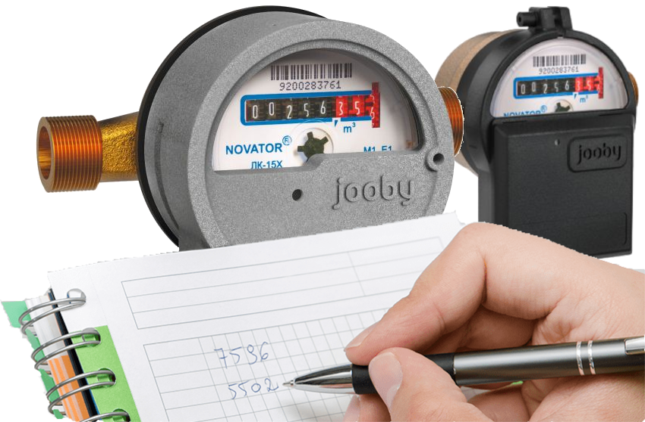

Installation. Activation
- JOOBY AQUARIS RMS 203. Installation
- RM 4PU/4PI Radio Module. Installation

Description of work. Control. Commands. Parameters
- Radio Module description of work. Commands. Parameters
- Command and Parameter Examples

Jooby Development
- Message documentation
- Message encoders/decoders
- Message encoders/decoders GUI (Demo)
- API for interacting with Jobby devices. Other documentation

Jooby water meter
- Ultrasonic JOOBY JWM - NEW!!!


