Gas Accounting  Jooby Devices  - Radio modules with sensor (RMS)  - Radio modules universal/multichannel (RM)  - Sensors and Cables | 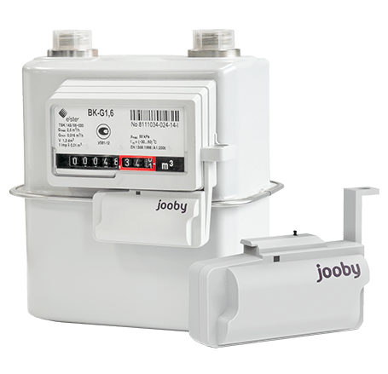

Installation. Activation
- Installation/Activation of the RMS Radio Module
- Installation/Activation of the RM 4PU/4PI Radio Module

Description of work. Control. Commands. Parameters
- LoRaWan module work description for Samgaz, Elster, Metrix gas meters
- Command and Parameter Examples

Jooby Development
- API for interacting with Jobby devices. Other documentation
- Message documentation
- Message encoders/decoders
- Message encoders/decoders GUI (Demo)

