Radio modules with sensor (RMS)
Jooby development  - API for interacting with Jobby devices. Other documentation  - Jooby message documentation  - Jooby message encoders/decoders  - Jooby message encoders/decoders GUI for test | 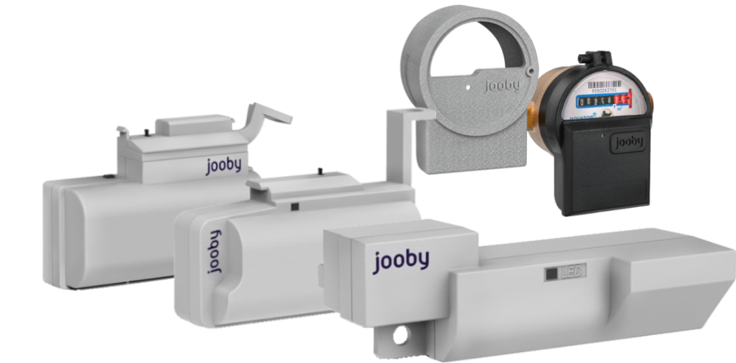

For gas metters
- Installation/Activation of the RMS Radio Module
- LoRaWan module work description for Samgaz, Elster, Metrix gas meters
- Command and Parameter Examples
Model | Аppearance | Resource type | Applicability | External antenna | Documentation
Jooby EPHIR RMS LoRaWAN GMEL10 100 | 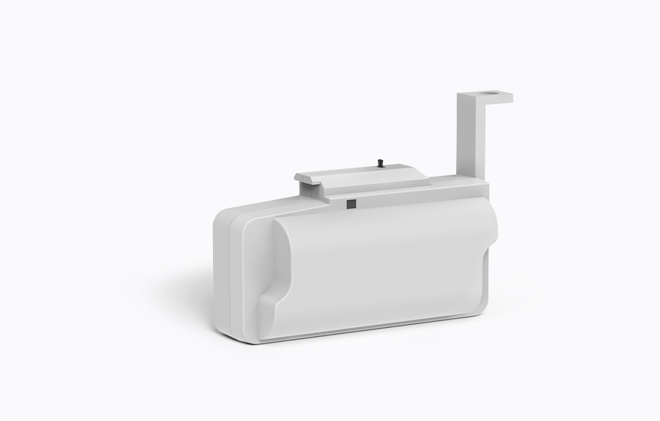 | Gas | G-Elster (BK-G1.6, BK-G2.5, BK-G4, BK-G6, BK-G10, BK-G16, BK-G25) | - | Specifications Operation Manual
Jooby EPHIR RMS LoRaWAN GMEL10 102 | 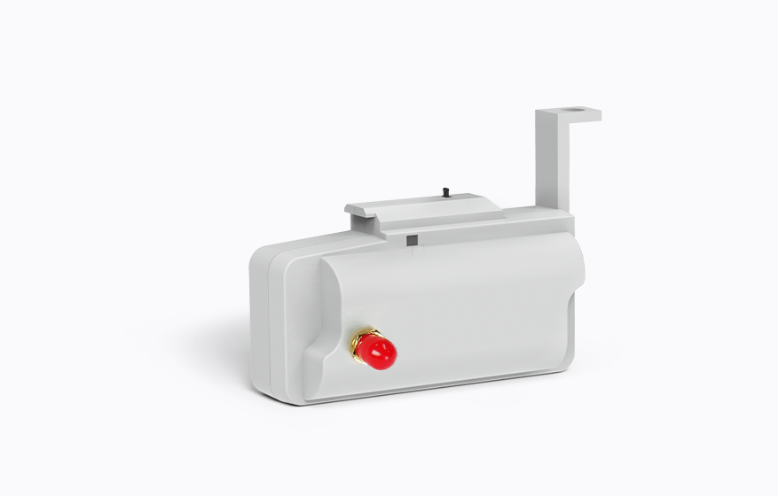 | Gas |  | 0.5 m | Specifications Operation Manual
Jooby EPHIR RMS LoRaWAN GMEL10 106 |  | Gas |  | 3.0 m | Specifications Operation Manual
Jooby EPHIR RMS LoRaWAN GMME10 103 | 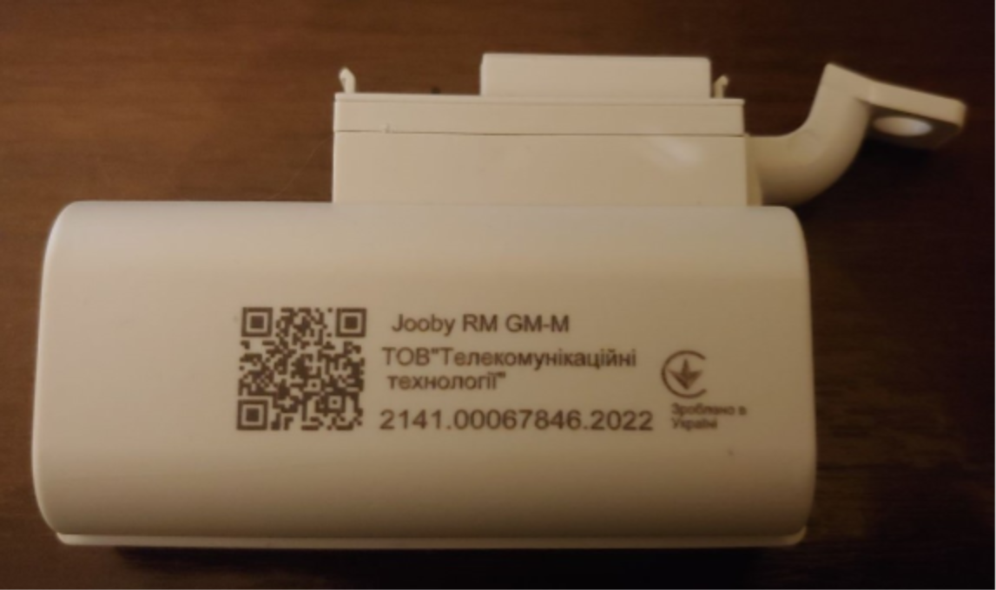 | Gas | G-Metrix (G1.6, G2.5, G4, G6, G10, G16) | - | Specifications Operation Manual
Jooby EPHIR RMS LoRaWAN GMME10 104 | 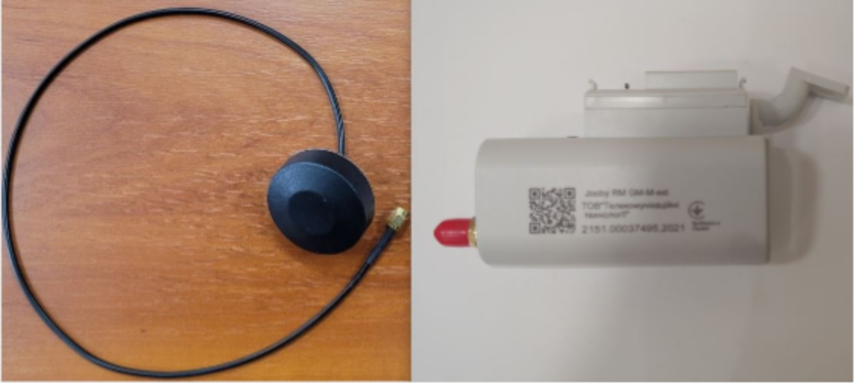 | Gas | G-Metrix (G1.6, G2.5, G4, G6, G10, G16) | 0,5 m | Specifications Operation Manual
Jooby EPHIR RMS LoRaWAN GMME10 107 | 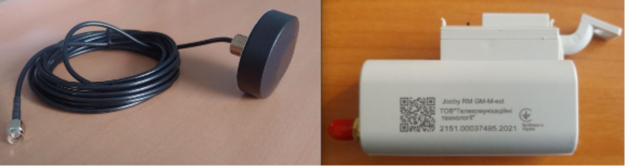 | Gas | G-Metrix (G1.6, G2.5, G4, G6, G10, G16) | 3,0 m | Specifications Operation Manual
Jooby EPHIR RMS LoRaWAN GMSG10 105 | 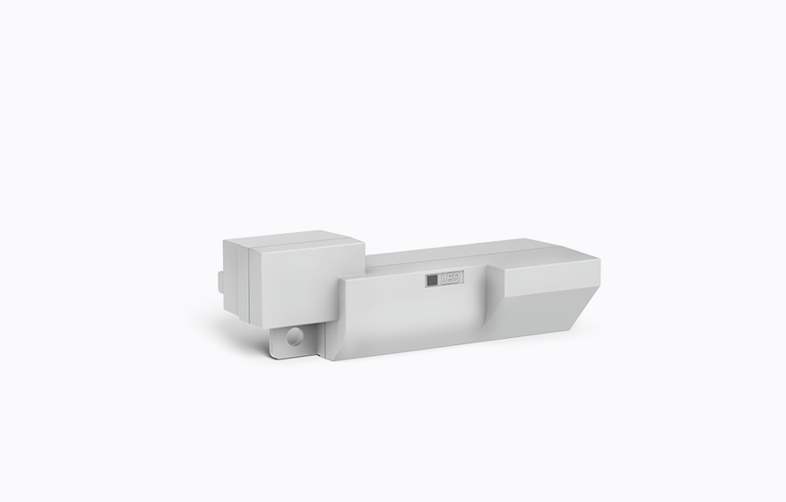 | Gas | G-SamGaz (G1.6, G2.5, G4, G6) | - | Specifications Operation Manual

For water metters
- JOOBY AQUARIS RMS. Installation
- LoRaWan module work description
- Command and Parameter Examples
Model | Аppearance | Resource type | Sensor type | Applicability | External antenna | Documentation
Jooby Aquaris RMS LoRaWAN WONO10 203 | 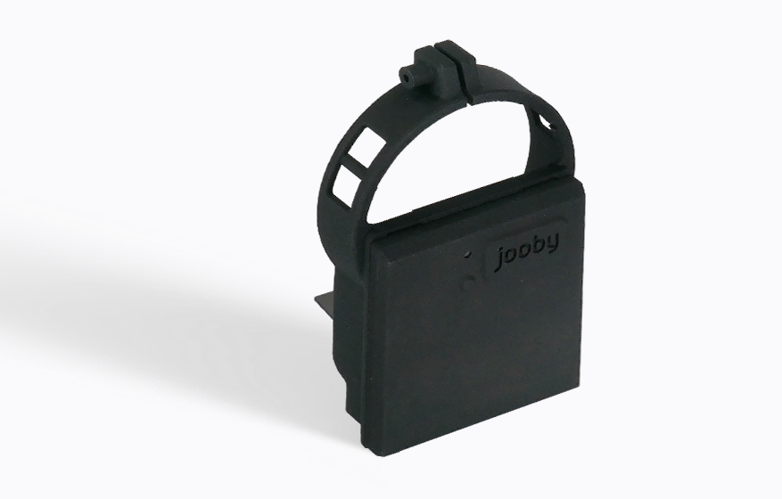 | Water | Optical | W-Novator_L (ЛК-15Х, Novator ЛК-15Г) | - | Specifications Operation Manual

