Sensors

Water Accounting
Jooby Sensors
Model | Аppearance | Resource type | Applicability | Sensor type | Radio module compatibility | Connection Cable | Documentation
Jooby Aquaris SNS WOAP01 100 | 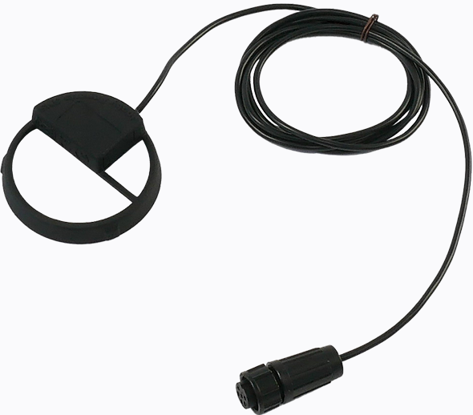 | Water | W-Apator JS Master + | Optical | Universal/Multichannel (RM) | -
Jooby Aquaris SNS WOAP02 100 |  | Water | W-Apator JS Smart + | Optical | Universal/Multichannel (RM) | -
Jooby Aquaris SNS WIAP01 100 |  | Water | W-Apator JS Master + | Inductive | Universal/Multichannel (RM) | -
Jooby Aquaris SNS WIAP02 100 |  | Water | W-Apator JS Smart + | Inductive | Universal/Multichannel (RM) | -
Third Party Manufacturers
Model | Аppearance | Resource type | Applicability | Sensor type | Radio module compatibility | Connection Cable | Documentation
Xylem Sensus HRI-B | 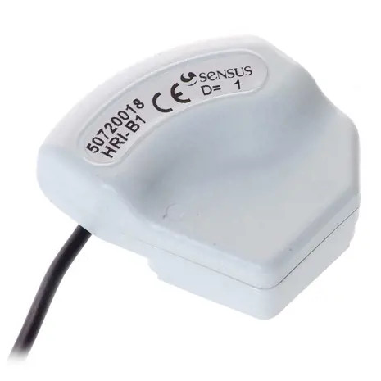 | Water | Sensus meters built since 2008 that are pre-equipped with an HRI modulator. www.xylem.com - Sensus HRI Sensor | Inductive | Universal/Multichannel (RM) | Jooby Cable 1PI 100

Gas Accounting
Third Party Manufacturers
Model | Аppearance | Resource type | Applicability | Sensor type | Radio module compatibility | Connection Cable | Documentation
ITRON 951.858.06* | 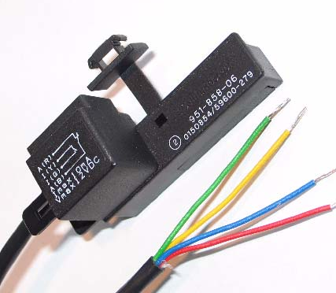 | Gas | Itron RF1 BKG2.5, 4…BKG6 | Magnet | Universal/Multichannel (RM) | Jooby Cable 1PI 100 | itron_951.858.pdf
 |  |  |  |  |  |  | Connecting to the Radio Module

Connection Cables
Model | Аppearance | Applicability | Radio module compatibility | Documentation
Jooby Cable 1PI 100 | 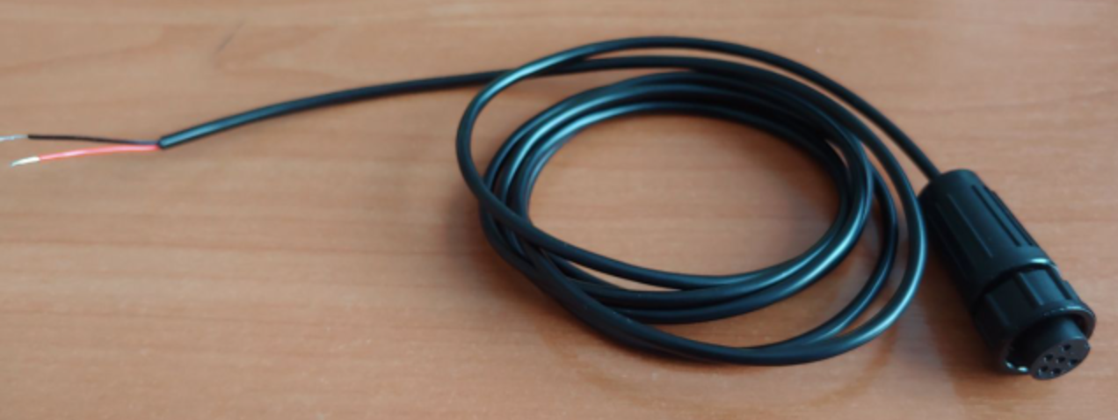 | For connecting external sensors | Universal/Multichannel (RM)
Jooby Splitter 1x2PU | 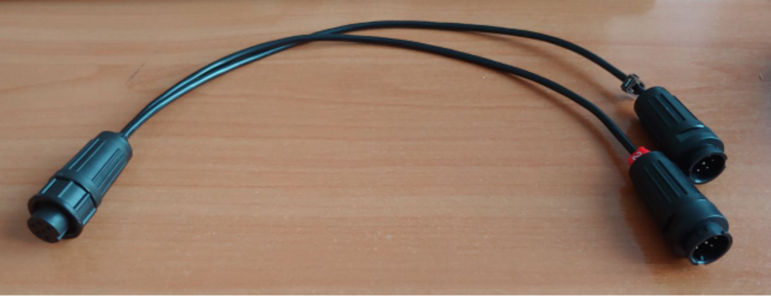 | For connecting external sensors | Universal/Multichannel (RM)
Jooby Splitter 1x4PU | 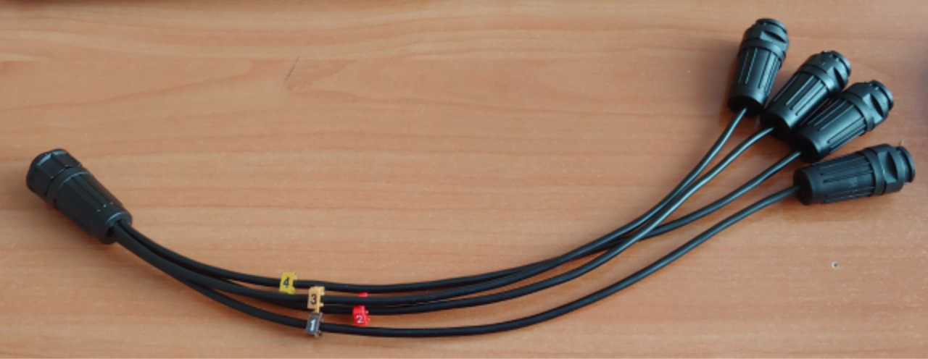 | For connecting external sensors | Universal/Multichannel (RM)

